Yili Liu, Riley Lessard, Kenny Le, Parker Nuzum, Scott Garner, Justin Llerena
FAMU-FSU College of Engineering 2525 Pottsdamer St. Tallahassee, FL. 32310
Team 310: NSWC Submersible Vehicle Kit
4/25/2025

Abstract
Our project’s goal is to develop a submersible vehicle kit for the purpose of providing a hands-on, educational experience for middle and high school students while introducing them to key principles of engineering, robotics, and underwater exploration. The submersible will be tethered and able to operate at depths up to 20 feet, it will feature a live-feed camera, active heading and depth control, and be controlled from an on land control station using a game controller for intuitive operation. The kit will have a final cost of under $500, making it accessible to educational programs. Using modular components, the students will be able to assemble and test their vehicles, building a deep understanding of buoyancy, propulsion, and feedback control systems.
A key aspect of our submersible vehicle kit is the integration of a XRP microcontroller from SparkFun which will control the motors and communication between the control station and the vehicle. This microcontroller, along with upgraded components and overall design will allow us to upgrade from the Sea Perch Kit, one of our parallel project goals.
This project is significant in promoting STEM in education at the middle and high school level. It bridges the gap between engineering theory and practical application. Students will gain first hand experience otherwise unavailable with traditional curriculum. By making advanced engineering concepts approachable and affordable, we hope this kit will be a pivotal tool in inspiring the next generation of innovators and preparing them for futures in engineering.

Acknowledgement
- We would like to extend our sincere gratitude to the Naval Surface Warfare Center (NSWC) Panama City Division for sponsoring our senior design project. Their support not only provided the foundation for our submersible vehicle kit but also gave us the opportunity to work on a project with real-world impact and educational value. Their encouragement toward STEM education inspired the goals and direction of our work.
- We are also deeply thankful to our faculty advisors, Dr. Shayne McConomy, Dr. Linda DeBrunner, and Dr. Damion Dunlap, for their continuous guidance, technical insight, and patience throughout this project. Their mentorship helped us navigate challenges, refine our design, and stay grounded in practical engineering solutions.
- Special thanks to SparkFun Electronics and Experiential Robotics Platform (XRP) for providing critical components and technical documentation. Access to development boards, firmware tools, and educational resources played a key role in our system integration and software development.
- Finally, we’d like to thank our families, peers, and lab assistants who supported us through long build sessions, test runs, and prototype iterations. Their help with logistics, feedback, and moral support kept us motivated and focused, especially during the most challenging stages of the project.

Table of Contents
Abstract…………………………………………………………………………………………… 2
Disclaimer………………………………………………………………………………………… 3
Acknowledgement………………………………………………………………………………... 4
List of Tables……………………………………………………………………………………… 7
List of Figures…………………………………………………………………………………….. 8
Notation…………………………………………………………………………………………… 9
Chapter One: …………………………………………………………………..………………..12
1.1 Project Scope……………………………………………………………………………. 12
1.2 Customer Needs…………………………………………………………………………. 14
Introduction………………………………………………………………………………….. 14
Explanation of Results………………………………………………………………………. 14
1.3 Functional Decomposition………………………………………………………………. 17
Figure 1: Functional Hierarchy Chart……………………………………………………….. 18
Table 3: Cross Reference Table ……………………………………………………………...21
Discussion of Results …………………………………………………………….22
Conclusion ……………………………………………………………………….25
1.4 Target Summary ………………………………………………………………………….26
1.5 Concept Generation ……………………………………………………………………...33
Concept 1: Tetra-Prop Drive ……………………………………………………..35
Concept 2: Modular Hull Design ………………………………………………...35
Concept 3: Trimaran-Style Propulsion …………………………………………..35
Concept 4: Biomimetic Fish Propeller …………………………………………..36
Concept 5: Dual-Chamber Buoyancy Control …………………………………...36
1.6 Concept Selection ………………………………………………………………………..39
Table 6: Pairwise comparison (Criteria weights) …………………………………………….46
Chapter Two: ……………………………………………………………………………………55
2.1 Risk Assessment …………………………………………………………………………55
Emergency Response Procedures ………………………………………………..65
List emergency response contact information: ……………………………………………….65
Safety review signatures ………………………………………………………………………..66
Introduction ………………………………………………………………………66
Team 310 Submersible Vehicle Kit: Work Breakdown Structure (WBS) ………67
Major Deliverables ………………………………………………………………67
WBS: Detailed Tasks and Sub-tasks ……………………………………………..67
Summary …………………………………………………………………………74
2.3 Spring Project Plan ………………………………………………………………………75
Table 9: Spring Schedule ………………………………………………………………………76
Appendices ……………………………………………………………………………………….78
Appendix A: Code of Conduct …………………………………………………………………..79
Methods of Communication ……………………………………………………..82
Individual and Team Goals: ……………………………………………………...83
Appendix B: Functional Decomposition ………………………………………………………...87
Appendix C: Target Catalog ……………………………………………………………………..88
Appendix D: Concept Generation ……………………………………………………………….89
Appendix E: Concept Selection ………………………………………………………………….94
References ………………………………………………………………………………………..95

List of Tables
Table 1: Customer Needs and Interpreted Needs………………………………………...15
Table 2: Functional Decomposition Table……………………………………………….19

Table 3: Cross Reference Table………………………………………………………….21
Table 4: Target Catalog…………………………………………………………………. 32

Table 5: Pugh Charts……………………………………………………………………..42

Table 6: Pairwise Comparison Chart…………...………………………………………..45

Table 7: Pairwise comparison……………………………………………………………46
Table 8: Analytical Hierarchy Process…………………………………………………...47
Table 9: Bill of Materials………………………………………………………………...50

List of Figures
Figure 1: Functional Hierarchy Diagram………………………………………………...18
Figure 2: Morphological chart…………………………………………………………...38
Figure 3: House of Quality………………………………………………………………40
Figure 4: Submersible Vehicle System Diagram………………………………………...52

Notation
A17 | Steering Column Angle
A27 | Pan Angle
A40 | Back Angle
A42 | Hip Angle
AAA | American Automobile Association
AARP | American Association of Retired Persons
AHP | Accelerator Heel Point
ANOVA | Analysis of Variance
AOTA | American Occupational Therapy Association
ASA | American Society on Aging
BA | Back Angle
BOF | Ball of Foot
BOFRP | Ball of Foot Reference Point
CAD | Computer Aided Design
CDC | Centers for Disease Control and Prevention
CU-ICAR | Clemson University - International Center for Automotive Research
DDI | Driver Death per Involvement Ratio
DIT | Driver Involvement per Vehicle Mile Traveled
Difference | Difference between the calculated and measured BOFRP to H-point
DRR | Death Rate Ratio
DRS | Driving Rehabilitation Specialist
EMM | Estimated Marginal Means
FARS | Fatality Analysis Reporting System
FMVSS | Federal Motor Vehicle Safety Standard
GES | General Estimates System
GHS | Greenville Health System
H13 | Steering Wheel Thigh Clearance
H17 | Wheel Center to Heel Pont
H30 | H-point to accelerator heel point
HPD | H-point Design Tool
HPM | H-point Machine
HPM-II | H-point Machine II
HT | H-point Travel
HX | H-point to Accelerator Heel Point
HZ | H-point to Accelerator Heel Point
IIHS | Insurance Institute for Highway Safety
L6 | BFRP to Steering Wheel Center

Chapter One

1.1 Project Scope
Project Description
The objective of this project is to design and construct a tethered submersible vehicle kit in collaboration with NSWC Panama City, Sparkfun, and Experiential Robotics. The final kit will be affordable, costing no more than $500 (excluding research and development expenses), and accessible to students of various ages and skill levels. It will serve as an educational tool to facilitate STEM outreach in lower education institutions by introducing fundamental engineering and scientific concepts.
Goals
The goals of this project are defined by the following criteria:
- Affordability:
  - Develop a submersible vehicle kit with a final cost of no more than $500.
- Performance:
  - Ensure the vehicle can operate reliably at depths of up to 20 feet, making it suitable for use in most pools.
  - Provide stable depth and heading control to maintain maneuverability underwater.
  - Enable real-time operation through a tethered live camera feed and a topside control station with video and control signals integrated.
  - Facilitate vehicle control via a standard game controller.

- Educational Utility:
  - Design the kit for ease of assembly, allowing students to gain hands-on experience with engineering concepts such as buoyancy, circuitry, programming, and control systems.
Markets
- Primary Market:
  - Naval Surface Warfare Center Panama City for STEM outreach initiatives.
  - Middle and highschools, where educators and students are the target audience.
- Secondary Market:
  - Commercial and government sectors that use remotely operated vehicles (ROVs), including industries like law enforcement, marine exploration, and underwater welding.
Assumptions
- The vehicle will operate in freshwater (pool) environments.
- The design will use a bare development board, preferably the XRP controller board, to keep costs low and functionality high.
- The target of the final retail price of the kit shall not exceed $500.
- Real-time camera feed and control signals will be supplied through a tether connected to a topside control station.

Stakeholders
Stakeholders of this project would include private/public educational programs and students, Dr. Damion Dunlap, Dr. Shayne McConomy, Dr. Oscar Chuy, Dr. Linda DeBrunner, and the Naval Surface Warfare Center (Panama City).

1.2 Customer Needs

Introduction

The customer has requested Team 310 design and build a tethered submersible vehicle kit in partnership with NSWC Panama City, Sparkfun and Experiential Robotics. They have requested the kit be affordable and accessible to students of various ages and skill levels while providing educational utility exceeding currently available robotics kits like the SeaPerch ROV and Experiential Robotics Platform. To start the design process, Team 310 began by identifying customer needs. These customer needs, whether explicitly stated or interpreted from customer statements, shall be used later in the design process to define targets, specifications, and requirements for the design and prototype.

Explanation of Results
Information was gathered through an in-person question-and-answer session with the customer. Team 310 recorded customer statements and interpreted the underlying needs. A summary of the customer needs, paired with corresponding requirements, is presented in table 1 below. This traceability ensures alignment between customer expectations and technical specifications.
Table 1: Customer needs and interpreted needs

Question | Customer Statement | Interpreted Need
1. What is the maximum retail price considered "affordable"? | Max cost of $500 for the final prototype excluding R&D. | Final kit is affordable and accessible for educational use, final prototype < $500.
2. Is 20 feet the real max depth or should it be designed for a safety margin that is deeper? | Vehicle is intended for pool use, 20 foot depth is plenty. | Vehicle can operate at typical pool depths.
3. Specific educational objectives? | All the concepts of the SeaPerch kit plus the basics of feedback controls. | Kit teaches students STEM concepts including basics of feedback control.
4. Size and weight restrictions? | Derived from the affordability of the vehicle. No restrictions. | Vehicle makes use of efficient design to limit material costs.
5. Will the tether carry both power and control signals to the vehicle? | Both possibly, but no requirement. Mainly for retrieval. | A tether is present for retrieval.
6. Skill level of end user? | Grades K-12 but targeted primarily at middle school students. | Kit has educational value for students in the middle school to high school range.
7. What quality footage should the camera produce? Is there a need for different viewing modes such as night vision, thermal, etc. | No specific requirement, but the camera should be accessible to the user. | Area for vehicle camera should be modular and user accessible.
8. How should the footage be viewed? Recording or live? | The video should be live streamed to a top-side “control station.” | Vehicle should provide a video live feed viewable at the surface.
9. How much required assembly is allowable? Should the kit be ready to go or partially assembled, fully assembled by user, etc. | Not a design requirement, will be figured out after the prototype is made. | Vehicle kits can be pre-assembled to varying degrees depending on use cases.
10. What environments will the device be used in? Should we account for saltwater corrosion/currents, etc? | Pool use only. | Vehicle can withstand exposure to typical chemicals used in swimming pools..
11. Are there existing resources, components, etc that we should utilize from the partners? | Sparkfun, Deca/WPI. We have outside resources to help us with stuff like coding libraries. | Vehicle to use Sparkfun/Deca/WPI components and software whenever possible.
12. What are key performance metrics that need to be met? Speed, acceleration, etc. | Compare it to a stock seaperch kit. Improve upon it. Don’t be slower than the stock kit. | Vehicle should outperform the SeaPerch kit.
13. How should the vehicle be controlled? | The vehicle should be controlled by a game controller from the top-side “control station.” | Vehicle control should be done through a game controller.
14. Should control of vehicle be "gamified" or allow students to have raw/unassisted control of vehicle. | Yes, raw control access for educational purposes like adjusting gain but not to begin with. | Vehicle control settings can be accessed and customized by the end-user if they desire.

1.3 Functional Decomposition
Introduction
The functional decomposition of the submersible vehicle kit breaks down the overall operation of the system into its fundamental components and sub-functions. This process helps in understanding how each part of the system contributes to the overall project goals and ensures that all requirements are met. The purpose of this decomposition is to clarify the design's functionality by defining specific actions the system will perform, starting from broad goals down to detailed, actionable tasks. By systematically dividing the system into smaller, manageable functions, we aim to align the design with the sponsor's needs, such as affordability, ease of assembly, and educational value for middle and high school students. This report includes visual representations of the hierarchy of functions, as well as a cross-reference table to connect functions with customer needs. Through this process, we identify relationships between subsystems, ensuring that the design promotes smart integration across all functional areas.

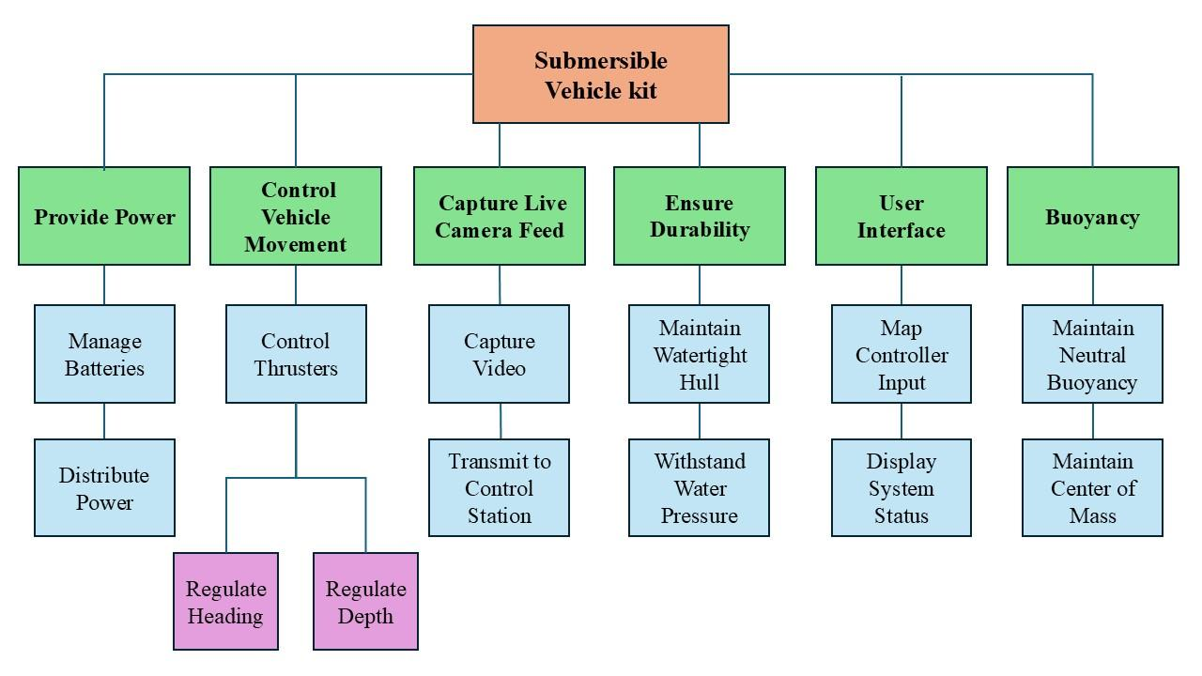
Figure 1: Functional Hierarchy Diagram

Table 2: Functional Decomposition Table

Major Functions | Sub-functions | Description | Related Customer Needs
 | - Control thrusters | Adjusts thruster power and direction to move the vehicle forward, backward, and laterally. | Depth and heading control, user-friendly game controller
  Control Vehicle Movement
 | - Regulate heading | Maintains and adjusts the vehicle's orientation underwater. | Depth and heading control
 | - Regulate depth | Adjusts buoyancy to control vertical movement (up/down) in the water column. | Withstand 20 feet depth, educational use
Provide Power | - Supply power to thrusters | Delivers sufficient electrical power to the thrusters for propulsion. | Reliable system, compatibility with educational robotics
 | - Power control system | Delivers regulated power to all subsystems including the camera, controller, and sensors. | Reliable and simple to use, powered by tether
Capture Live Camera Feed | - Capture video signal | Uses an underwater camera to capture real-time footage from the vehicle. | Live camera feed for educational observation
 | - Transmit video feed to control station | Sends live video feed from the underwater camera to the user’s control station above the water surface | Easy to view real-time footage, camera accessibility
Control via User Interface | - Map controller input | Translates user inputs (joystick movements, buttons) into commands for controlling the vehicle. | Game controller interface, intuitive control for students
 | - Display system status | Provides feedback on the vehicle's operational status (e.g., depth, heading, battery levels) at the control station. | Educational, user-friendly feedback
Regulate Buoyancy | - Adjust buoyancy for neutral positioning | Manages buoyancy by adjusting weights or ballast, allowing the vehicle to maintain neutral buoyancy at a given depth. | Hands-on learning about buoyancy and center of mass
 | - Fine-tune balance and center of mass | Allows users to reposition weights or ballast to achieve better balance underwater. | Educational focus on buoyancy and balance
Ensure Durability | - Withstand water pressure | Ensures the vehicle is waterproof and can handle pressure at depths up to 20 feet. | Safe for use up to 20 feet in pool environments
 | - Protect electrical components from water | Seals and protects sensitive electrical components to ensure durability during repeated submersion. | Robust and reliable design
Tethered Data & Power | - Transmit data via tether | Uses a tether to transmit control and video data between the control station and the vehicle. | Tethering for power and signal transmission
 | - Manage battery power supply | Regulates and distributes power from the battery to all vehicle systems, ensuring continuous operation during underwater use. | Reliable operation, teaches power management, minimal dependence on external power sources.

Table 3: Cross Reference Table

Major Functions | Minor Functions | Ease of Operation | Depth Control | Real Time Feedback | Power Efficiency | Educational Value
Control Movement | Adjust Speed | x
 | Change Direction  (Pitch/Yaw) | x
Manage Buoyancy | Ascend |  | x
 | Descend |  | x
 | Maintain  Depth |  | x
Power & Communication | Power Management |  |  |  | x
 | Data Transmission |  |  | x
Feedback Systems | Depth Monitoring |  | x |  |  | x
 | Pressure Sensing |  | x |  |  | x
Visual Feedback | Capture Video | x |  | x
 | Stream Video to Controller | x |  | x

Discussion of Results
The functional decomposition process for the submersible vehicle kit provides a comprehensive framework for understanding the system's core functionalities and their interrelationships. This structured approach allows for clear identification of the requirements necessary to meet customer needs while facilitating a robust design process. The main function of the Submersible Vehicle Kit , encapsulates the overall goal of delivering a reliable and educational underwater vehicle. By breaking this down into key sub-functions such as Control Vehicle Movement, Provide Power, and Capture Live Camera Feed, we ensure that every aspect of the design is considered, from propulsion to user interaction.

Key Findings
- Control Vehicle Movement:
  - This sub-function emphasizes the importance of navigation and stability. The inclusion of thruster control, heading regulation, and depth management demonstrates a commitment to creating a responsive and user-friendly experience. These features align directly with educational objectives, allowing students to learn about dynamics and control systems through hands-on engagement.
- Provide Power:
  - The decision to manage battery power supply rather than relying solely on tethered power ensures that the vehicle remains operational without being tethered to a power source at all times. This promotes greater exploration and learning opportunities, as students can navigate the vehicle freely within the confines of a controlled environment.
- Capture Live Camera Feed:
  - Integrating live video streaming capabilities addresses the need for real-time feedback, enabling operators to engage more deeply with the underwater environment. This aligns with the educational goal of providing a rich, interactive learning experience for students, fostering skills in observation and analysis.
- Control via User Interface:
  - A focus on user interface development ensures that the control mechanisms are intuitive and accessible, catering to the target demographic of middle and high school students. By mapping controller inputs and displaying system statuses, we enhance usability and facilitate smoother learning experiences.
- Regulate Buoyancy:
  - Adjusting buoyancy and fine-tuning balance are critical for operational effectiveness at various depths. These features not only ensure the vehicle's functionality but also provide an opportunity for students to experiment with physical principles such as buoyancy and center of mass.
- Ensure Durability:
  - By addressing the need for water resistance and protection of electrical components, the design incorporates necessary safeguards to ensure long-term usability in freshwater environments. This consideration is vital for educational applications, where reliability is essential.
Summary
This report presents a detailed functional decomposition of the submersible vehicle kit designed for educational use among middle and high school students. The primary objective of the project is to create an affordable, user-friendly, and interactive underwater vehicle that enhances learning in key scientific concepts, such as buoyancy, control systems, and electronics. The decomposition process breaks down the main function, Submersible Vehicle Kit Operation, into several critical sub-functions:
- Control Vehicle Movement: Ensures navigational capabilities, allowing students to understand principles of motion and stability.
- Provide Power: Focuses on battery management to ensure reliable operation without dependency on tethered power, promoting exploration.
- Capture Live Camera Feed: Integrates real-time video capabilities for enhanced user engagement and observational learning.
- Control via User Interface: Develops intuitive controls that cater to the target demographic, facilitating a seamless user experience.
- Regulate Buoyancy: Addresses the need for operational effectiveness and provides hands-on experimentation with buoyancy principles.
- Ensure Durability: Ensures the vehicle can withstand operational conditions, safeguarding electrical components and enhancing longevity.
The functional decomposition illustrates the interconnectedness of these components, emphasizing their role in achieving the project's educational and operational goals. By clearly defining each function and its contributions to the overall system, the project establishes a solid foundation for subsequent design iterations, prototyping, and testing.

Conclusion
Overall, the functional decomposition has highlighted the interconnectivity of various components within the submersible vehicle kit, emphasizing the importance of each function in delivering a successful educational tool. The systematic breakdown of major functions into actionable sub-functions aligns with the project’s goals and customer needs, ensuring a comprehensive approach to the design and development process. As the project progresses, this structured understanding will serve as a foundation for refining designs, conducting testing, and ultimately delivering a product that meets educational and operational objectives

1.4 Target Summary
Introduction
The following document outlines the targets and metrics established for the development of the submersible vehicle kit. Targets were derived based on the functional requirements of the vehicle, customer needs, and the educational goals of the project. By setting measurable targets, we ensure that each function of the submersible vehicle can be tested, validated, and optimized for performance. The targets focus on critical aspects to operation such as navigation, control, energy efficiency, and operational durability, ensuring the vehicle meets both technical requirements and user experience expectations. Several additional targets were established related to portability, packaging, and data transmission to address practical considerations for end users, such as students and educators.
Each target is accompanied by a specific metric with units. This is essential for measuring the performance of the vehicle and confirming it meets the defined target. The document also details the methods of validation for targets and the tools required to assess the submersible’s functionality. By defining clear, testable targets, this document serves as a roadmap for guiding the design, development, and testing phases of the submersible vehicle project, ensuring all critical functions are met.
Derivation of Targets
The targets and metrics for the submersible vehicle kit were derived by analyzing both the technical requirements of the project and the educational goals outlined by the customer. Each target reflects the need to provide a balance between performance, durability, and ease of use, particularly for middle and high school students engaging in hands-on learning experiences.
In developing the submersible kit, we identified key functional targets as well as additional targets to ensure the vehicle operates effectively within the constraints of the project. The primary functional targets focus on critical aspects of underwater operation, such as maintaining heading, depth, buoyancy, and overall durability, while additional targets address factors like weight, packaging, data transmission, and safety. The targets and metrics for the submersible vehicle were derived from customer needs and the functional decomposition of the design. Customer statements were collected and interpreted into needs, which were documented to guide the design process. These needs were then used to break down the submersible’s functions into specific, measurable goals. For each function, a target and corresponding metric was determined to ensure that the function was adequately met. Critical targets and metrics were assigned to the functions essential for vehicle operation, ensuring that the submersible would meet both performance and usability requirements. The in-depth derivation process for the critical targets and metrics is detailed below.

Critical Targets and Metrics
Several targets are considered mission-critical for the success of the submersible vehicle kit and its operation in underwater environments. These targets are vital to the operation of the vehicle and directly impact user experience, vehicle safety, and functionality. Those determined critical either involve the basic integrity of the vehicle or basic control of the vehicle.
Regarding integrity of the vehicle, the vehicle must withstand water pressure without sustaining damage to the hull. The target for this function is for the hull to withstand water pressure at a 20 foot depth. The metric for this target is feet (depth). The ability to withstand pressure at 20 feet ensures the vehicle can operate in typical pool environments and meet the competition standards of Seaperch. Failure to withstand this pressure could compromise the hull’s integrity and the vehicle’s operational capability. Additionally, the vehicle must remain watertight at all operational depths. The watertight integrity of the hull is essential to protect internal electronics and components. Any water intrusion could lead to electrical damage, short-circuiting, or complete failure of the vehicle. Ensuring the hull remains watertight is critical for the vehicle's long-term functionality and reliability. The target for this function is for the hull to take on 0 milliliters per hour of water. The metric for this target is milliliters per hour.
Regarding basic vehicle control, it must be able to regulate depth and heading accurately. For regulating heading, the vehicle should maintain heading within 5 degrees of the desired input from the controller. The metric for this target is degrees. Precise heading control is crucial for effective navigation, allowing the operator to maintain course during underwater exploration. Deviation from the desired heading could lead to instability or difficulty in steering, negatively impacting the learning experience. For regulating depth, the vehicle should ascend or descend in accordance with the desired input at a rate measured in feet per second. The metric for this target is feet per second. Accurate depth control allows the user to explore different underwater levels and maintain control of the vehicle’s position. This is essential for demonstrating concepts of buoyancy and pressure in an educational setting. Inability to control depth reliably would limit the effectiveness of the vehicle for hands-on learning. Finally, the vehicle must maintain neutral buoyancy, the target being that the vehicle’s depth should not change by more than 3 inches over a 1-minute period while idle. The metric for this target is inches per minute. Achieving neutral buoyancy is critical for stable operation. Neutral buoyancy allows the vehicle to hover in place without rising or sinking, making it easier for students to observe the vehicle’s behavior and experiment with balance and mass distribution.

Methods of Validation and Discussion of Measurement
The method of validation for each target will vary, testing will require a variety of tools for measuring specific metrics. Some tests will occur in simulated operating environments while others will occur in real-world operations. Similarly some tests will occur on individual systems apart from the vehicle, while others will require use of a full-scale prototype. The tools needed for the validation of targets as well as the methods of testing they are to be used for are listed below:

- Gyroscope: Used to measure metrics that have degrees.
  - For example, regulation of heading and maintaining center of mass.
  - Measuring the maintenance of center of mass will be done by attaching a gyroscope to the top or bottom center of the submersible kit hull and leaving it submerged while recording its readouts. A stopwatch will be started and at the one minute mark if the gyroscope does not read a difference of greater than 5 degrees from the initial reading when first submerged and this can be repeated, then the target is hit.
- Stopwatch: Used to measure all metrics related to time.
- Power meter: Used to measure power drawn from submersible vehicle kit, can be plugged into tether.
- Measuring tape: Used to make any measurements of metrics in inches/feet,etc.
- Clear plastic bin: Will be used for depth measurements to simulate a pool.
  - For example, measuring neutral buoyancy can be done by marking a level underwater and making two marks 3 inches above and below that level. The submersible will then be placed in the water with a chosen point on the bins level mark and a stopwatch will be run for one minute. If the submersible’s chosen point does not cross over either marks made 3 inches apart from the initial level mark and this can be reproduced multiple times, the submersible will have reached this target.
- Computer: Used to play the live feedback from the submersible’s camera. The feed’s resolution can be extracted using software such as VLC media player.
- Weight Scale: A weight scale will be used to measure metrics related to weight in kg or pounds.
- 20x18x12 Shipping Box: If a standard large shipping box of these dimensions can fit all the parts of the vehicle submersible kit, this target will be met.

Target Summary
In developing the submersible kit, we identified some key functional targets to ensure the vehicle operates effectively within the constraints of the project. The primary functional targets are designed around critical aspects of underwater operation, which would include maintaining heading, depth, buoyancy, overall durability, etc.
Live camera feed is one of many core features, allowing the user to visually monitor underwater environments. Providing HD video at 720p and 30 frames per second or better, which ensures that the submersible delivers a clear real time video feed.
Regulating heading and depth is essential for user control and stability during underwater exploration. The submersible is expected to maintain heading within 5 degrees of the controller’s input and to ascend or descend at the desired speed. This ensures precise navigation and ease of control for the operator.
Energy efficiency is a major design consideration for any tethered and battery-operated vehicle. The target of at least 20 minutes of runtime, provides the users enough time to engage in demonstrations without frequent interruptions or recharge. The focus on watts or minutes allows for optimizing the power system, ensuring a balance between performance and operational time.
Maintaining neutral buoyancy and center of mass is critical for stable operation in a controlled environment such as a pool. Neutral buoyancy ensures the submersible can hover without significant vertical drift, while proper balance in the pitch, roll, and yaw axes keeps the vehicle steady.
To enhance durability, we set targets for water pressure resistance and watertight integrity. The vehicle must withstand the pressure at a depth of 20 feet, which aligns with the Seaperch competition guidelines. Additionally, the hull must remain watertight to make sure there will be no damage to internal electronics. Thrust power is another crucial target, it will be responsible for vehicle acceleration and deceleration. It will effectively provide a responsive and engaging user experience.
The additional targets are just as important to the overall success of the project. We set a weight limit of 20 kilograms for the vehicle to ensure it remains portable and easy to handle, particularly in educational settings where students may need to lift and transport the vehicle. The packaging target is also essential for shipping and storage, ensuring the entire kit fits within a 20x18x12 inch box, which is a standard shipping size.
Another key additional target is data transmission, as the kit is tethered and relies on continuous communication between the controller and the vehicle. The target for data transmission speed, measured in milliseconds, ensures minimal lag between user input and vehicle response. Finally, the target for automatic surface recovery, a safety feature that ensures the vehicle can float back to the surface in the event of a power failure or system malfunction.
These targets were chosen with both technical feasibility and educational impact in mind. Each target directly supports the vehicle's use as a learning tool, aligning with the project’s goals to foster a hands-on learning experience in a safe, engaging, and affordable manner. These targets ensure that the vehicle is reliable, durable, and responsive within a cost effective and accessible design.
Level of Importance and Consequences of Failure
Each target was assigned a level of importance based on how critical it was to the submersible’s core functions. Heading and depth regulation, water pressure regulation, neutral buoyancy, and watertight integrity were considered the highest priority because failure in these areas would severely limit the submersible's operability. For example, if the hull fails to remain watertight, the entire system could short-circuit, making it inoperable. Another example would be, if the submersible cannot maintain its heading within the 5-degree tolerance or fails to regulate its depth, it could drift uncontrollably, making precise underwater exploration impossible. If the vehicle cannot maintain a stable heading or depth, it will be difficult for users to control, frustrating the learning process and detracting from the vehicle's educational value. In contrast, while targets like packaging and data transmission speed are important, their failure would not render the submersible inoperable. However, issues with data transmission (e.g., delays in user input reaching the submersible) would affect the quality of the user experience and diminish the sub’s interactivity, making it less engaging.
Table 4: Target Catalog (Critical Targets Highlighted)

Function | Target | Metric
Regulate Heading | The submersible kit should maintain heading within 5 degrees of desired input heading from the controller. | degrees
Regulate Depth | The submersible kit should ascend or descend in accordance to the desired input from the controller. | feet/second
Capture Live Camera Feed | Provide live and HD visual feedback on a screen the operator can see. | 720p 30fps
Batteries/Power | Optimize energy usage / maximize run time. Targeting a run time of at least 20 minutes. | Watts (W) or Minutes
Maintain Neutral Buoyancy | Submersible vehicle depth while idle should not change by more than 3 inches in one minute. | inches/minute
Maintain Center of Mass | When submerged and idle, a submersible kit should not roll, pitch, or yaw by more than 5 degrees/min. | degree/min
Maintain Watertight Hull | The hull of the submersible kit should take on 0 ml/hr of water when submerged. | milliliter/hour (ml/hr)
Withstand Water Pressure | The submersible vehicle kit should be fully operational and take on no damage as a result of pressure at a depth of 20ft underwater. | feet (ft) [depth]
Thrust power | Provide quick acceleration and deceleration to allow vehicle to reach target speed rapidly | meters/second

Additional Targets

Description | Target | Metric
Vehicle Weight | Submersible should weigh less than 20 kilograms. | kg
Kit Packaging | The entire submersible vehicle kit (unassembled) should fit in a standard 20x18x12 inch shipping box. | inch
Data transmission | Ensure continuous communication for transmitting control signals from controller to vehicle over a 50ft tether | milliseconds
Automatic Surface Recovery | Ensure the vehicle can float back to the surface in case of failure or power loss | foot/second

1.5 Concept Generation
Introduction
Concept Generation critical step in the design process in which potential solutions to satisfy customer needs are explored. Design concepts include working principles, technologies, and engineering design knowledge applicable to problem and design. Concept generation allows the problem and solution to be looked at from a different perspective to better inform later design. These perspectives include biomimicry, forced analogy, anti-problem and the use of a morphological chart, each providing unique concepts. Through the concept generation process, 3 high fidelity concepts and 5 medium fidelity concepts were generated and detailed below. These are the concepts most likely to make it into our final design. The full list of concepts generated are detailed in Appendix A and grouped according to what method was used for generation.
1.5.1 High-Fidelity Concepts
Concept 1: PVC Hull
PVC pipe main body with a sealed acrylic dome at the front for the camera, two weighted cylinders on the left and right bottom side of the main body for balancing and buoyancy control. Two rearward facing thrusters on left and right of the body for forwards and backwards movement along with rotation. Two thrusters facing downward at a 45 degree angle from the center axis of the body for ascent and descent motion. A tether going through the rear of the body secured using a threaded cap along with epoxy for waterproofing. Controller board will be inside the body and will control the propellers along with communication through tether with the control station.
Concept 2: PVC Frame
Body of the vehicle is a cube shaped PVCframe. All components mounted externally to frame. Floats are placed on top of the frame and weights on bottom for neutral buoyancy and stability. Waterproof camera mount in the center of the frame along with the controller board in a small waterproof box. Waterproof ROV thrusters are mounted vertically on the four corners of the frame with propulsion and vehicle control similar to a typical quadcopter drone. A 50 foot tether is attached to the microcontroller box and provides power over 14 AWG speaker wire and communication over ethernet. Tether is run to a standard lead-acid car battery for power and live-feed/communication runs to a PC, both present at the onshore control station. Vehicle control input is done through a standard game controller and live-feed displayed on the PC monitor.
Concept 3: Submarine Style
Body is a PVC pipe and the design resembles a submarine. A single motor and propeller mounted at the rear of the vehicle provides forward and backwards movement. The has internal weights to make it only slightly positively buoyant. For heading and depth control surfaces (bow planes and diving planes) are used, requiring forward motion of the vehicle to be effective. These control surfaces are actuated using servos within the body of the vehicle. For power, a sealed LiPo battery is mounted inside the vehicle and accessible through a waterproof door on the body. A sealed acrylic dome at the front of the vehicle allows for a forward looking camera. The microcontroller is also mounted within the waterproof body. The tether is a 100 foot ethernet cable and provides the live-feed and communication from the vehicle to the on shore control station where the live feed is displayed onto a PC monitor and the vehicle is controlled with a standard game controller.

1.5.2 Medium Fidelity Concepts

Concept 1: Tetra-Prop Drive
A cylindrical body made of polycarbonate, featuring a waterproof compartment for the controller and power supply. Four propellers mounted at 45-degree angles for omnidirectional movement (forward, backward, side-to-side, and depth control). The vehicle achieves neutral buoyancy with distributed lead weights and foam inserts. The camera is mounted on a swivel for 180-degree field of view. The tether connects at the rear with a sealed plug, while an onboard microcontroller manages motor operations and signal relay.

Concept 2: Modular Hull Design
A submersible vehicle with a detachable cylindrical hull split into two main sections: one for power and propulsion, the other for camera and control systems. Propellers are mounted at the rear for forward motion and at the front for reverse. Two vertical thrusters handle depth control. Neutral buoyancy is achieved with adjustable ballast tanks. The transparent front section houses the camera for live video feed, and the modular design allows for easy component swapping. Tether connection runs through a watertight gasket at the back.

Concept 3: Trimaran-Style Propulsion
A trimaran-inspired design with a central hull and two smaller outriggers for added stability. The central hull holds the control electronics and power source, while the outriggers each have small propellers for forward and backward motion. Additional propellers beneath the main hull control depth. The camera is mounted at the front of the central hull with a wide-angle lens. Weights at the base of the outriggers provide stability, and the tether connects to the rear of the central hull through a waterproof seal.

Concept 4: Biomimetic Fish Propeller
A submersible with a streamlined body resembling a fish, designed for minimal drag in water. Instead of traditional propellers, the vehicle uses fin-like oscillating propulsion for forward motion, inspired by the movement of fish tails. Two small propellers mounted at the top and bottom provide depth control. Neutral buoyancy is maintained through adjustable internal weights and foam. The camera is located at the front, with the tether extending through a watertight seal at the top rear. This design focuses on quiet and efficient movement.

Concept 5: Dual-Chamber Buoyancy Control
A submersible with a dual-chamber design for enhanced buoyancy control. The main body is a rectangular acrylic shell, divided into two compartments: one for the electronics and propulsion systems, the other as an adjustable ballast tank filled with water or air for fine-tuning buoyancy. Two rear-mounted propellers handle forward and reverse motion, while vertical propellers control depth. The camera is housed in the front compartment with a protective dome, and a tether connects at the rear with a waterproof connector. The controller monitors and adjusts the ballast system to maintain neutral buoyancy and stability during operation.

Codes and Standards Applicable to Concepts
WiFi - IEEE 802.11- https://www.ieee802.org/11/
Bluetooth - https://www.bluetooth.com/specifications/specs/
Wire Gauges - ASTM standard B 258 - https://www.astm.org/b0258-18.html
Electrical Standards - OSHA 29 CFR 1910 - https://www.osha.gov/electrical/standards
IPX Waterproofing Standards - IEC 60529 - https://www.iec.ch/ip-ratings
PVC Pipe Standards - ASTM D1785-21a - https://www.astm.org/d1785-21a.html

Summary
The concept generation process is a critical step in the design of the submersible vehicle kit. Through various techniques such as biomimicry, forced analogy, anti-problem solving, and the use of morphological charts, the team has explored multiple potential solutions to satisfy customer needs. The design concepts generated involve key engineering principles, technologies, and creative approaches that directly address the vehicle's ability to maintain depth and heading control, provide live camera feedback, and withstand pressures at depths of up to 20 feet.
Three high-fidelity concepts and five medium-fidelity concepts have been developed to represent the solutions most likely to succeed in the final design. These include innovative designs using PVC, modular hulls, biomimetic propulsion, and advanced buoyancy control systems. The concepts consider factors such as ease of use, affordability, and durability, all aligned with the educational objectives of the project. The complete list of generated concepts is provided in the appendix, categorized by the method used for idea generation.
By exploring diverse concepts and refining their ideas through this process, the team has laid the groundwork for selecting and developing the optimal design solution for the submersible vehicle kit.
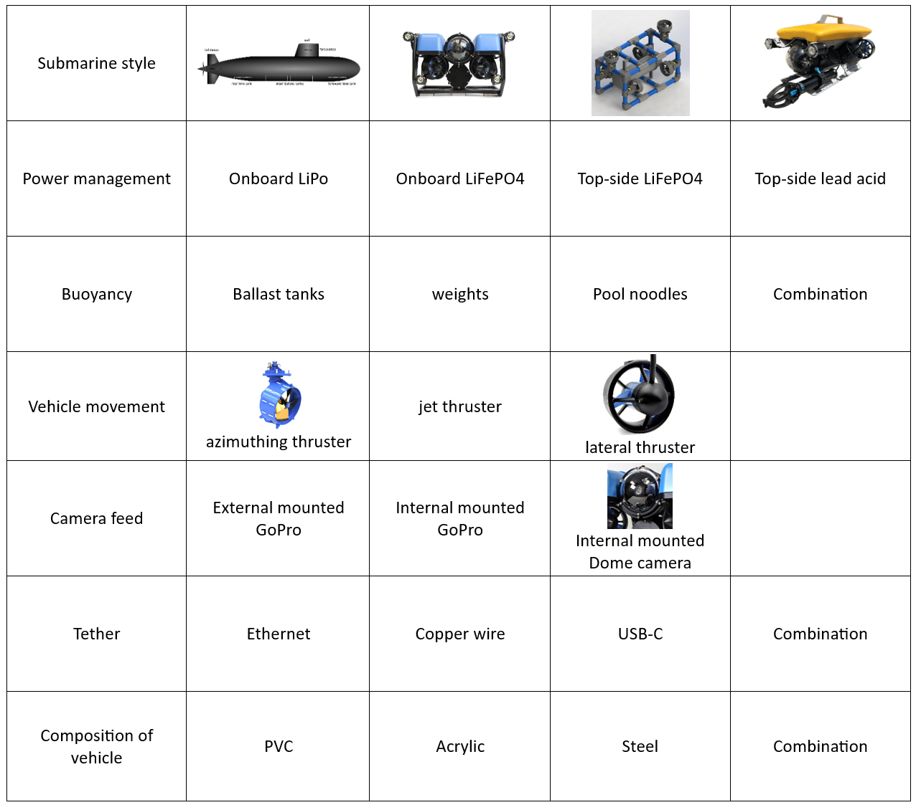
Figure 2: Morphological chart

1.6 Concept Selection
Introduction
In the design of our submersible vehicle kit, selecting the optimal concept is critical to ensure the final product meets customer needs and project requirements. Through the engineering decision-making process, we evaluated multiple high- and medium-fidelity design concepts, utilizing structured methodologies like the House of Quality, Pugh Charts, and Analytical Hierarchy Process (AHP) to systematically compare each design. These methods allowed us to balance technical performance, feasibility, and cost-effectiveness across various functional requirements, such as depth control, heading stability, camera feedback, and durability under water pressure.
This document presents our selection process, detailing how each chart was applied and the insights gained at each stage. Ultimately, the evaluation led us to designate one concept as the "winner," representing the best alignment with project goals. This final concept will guide the next phases of development, ensuring a robust, user-friendly, and cost-effective submersible vehicle for educational purposes.
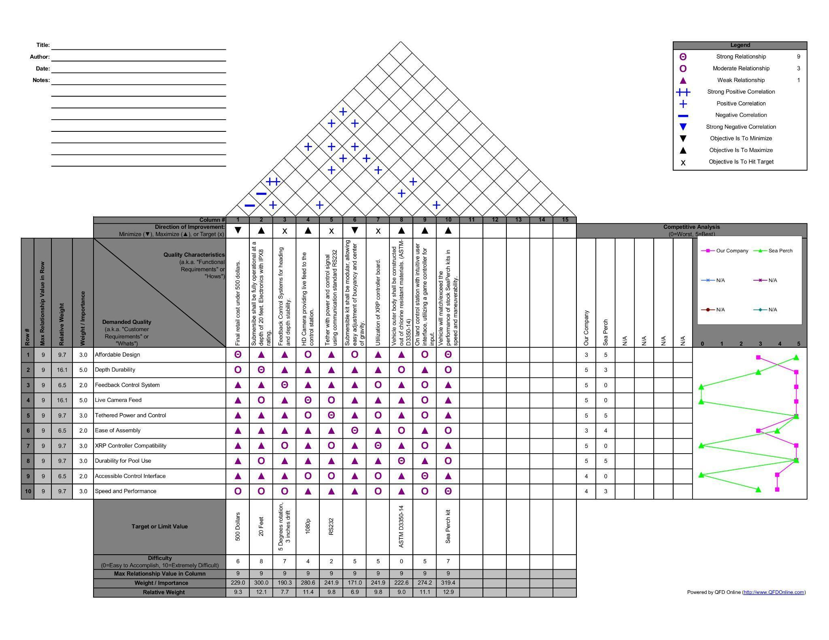
Figure 3: House of Quality

House of Quality

The house of quality in figure 3, is made of four main components: Customer Needs, Requirements, Relationship Matrix, and Technical importance. The relationship matrix shows the relationship between customer needs and the requirements. Requirements with stronger relationships to customer needs should then be prioritized. Using Excel, we are able to calculate the technical weight/importance value of each requirement, giving us further and definitive insight into which requirements should be prioritized higher in our design process. This process helps align our customer expectations with design, optimize our time and resource management in the design process, and gain new insight on potential trade-offs by giving a visual relationship between customer needs and requirements.
Through the use of the House of Quality, we can see that the order of importance from most to least for requirements are: 10, 2, 4, 9, 5, 7, 1, 8, 3, 6. This means our main three focuses should be on maintaining operational ability at a depth of 20 feet, being faster and more maneuverable than the sea perch kit, and having a live camera feed from the submersible back to the surface.
We see that we will stack up nicely against our “competition” the Sea Perch Kit from the competitive analysis chart, with Sea Perch falling behind mainly due to their lack of advance control and live feedback. We are expected to fall short in affordability and ease of assembly. This is expected due to the nature of our project, which is to be a better version of the Sea Perch Kit. We will have far more advanced capabilities so cost is expected to be higher and assembly will be more complicated due to additional parts.

Table 5: Pugh Charts

Criteria | Baseline: PVC Pipe Body
  Cube Frame Design
  Submarine Design
  Tetra-Prop Drive
  Trimaran-Style Propulsion
 | +1 | +1 | -1 | 0 | +1
  Buoyancy Control
 | +1 | +1 | -1 | +1 | +1
  Stability
 | +1 | 0 | +1 | +1 | -1
  Propulsion Efficiency
 | +1 | -1 | 0 | +1 | +1
  Maneuverability
Durability | +1 | +1 | -1 | -1 | +1
 | 0 | +1 | -1 | 0 | -1
  Ease of Assembly
Cost | +1 | -1 | 0 | 0 | -1
 | 0 | 0 | +1 | -1 | 0
  Battery Life
 | 0 | 0 | +1 | +1 | 0
  Camera Visibility
Total | +6 | +2 | -1 | +2 | +1

Pugh Chart
The results from Table 5: Pugh chart, evaluation indicate that the PVC Pipe Body baseline design remains the most aligned with the project’s priorities. While other alternatives, such as the Cube Frame Design and Tetra-Prop Drive, showed strong performance in specific areas, the PVC Pipe Body offers a balanced combination of affordability, ease of assembly, durability, and cost-effectiveness, which are critical to the project's goals. Its simplicity and adaptability make it an excellent choice for an educational kit designed for middle and high school students.
The Cube Frame Design, with a total score of +2, performed well in stability, ease of assembly, and durability, but its increased cost presents challenges for staying within the $500 price constraint. Similarly, the Tetra-Prop Drive also scored +2 due to strengths in propulsion efficiency and maneuverability, yet its complexity and potential challenges in battery life and cost make it less suitable for the project’s accessibility and affordability objectives.
The Submarine Design, with a score of -1, and the Trimaran-Style Propulsion, with a score of +1, exhibited significant drawbacks in areas such as cost, durability, and ease of assembly. These challenges limit their feasibility for an affordable and educational submersible vehicle kit.
In summary, the PVC Pipe Body baseline design provides the best alignment with the project’s priorities by meeting the criteria for affordability, durability, and ease of assembly, while also offering a practical and straightforward platform for educational purposes. It remains the most viable option for achieving the balance of performance and accessibility required by the stakeholders.

Pairwise Comparison
The Pairwise Comparison in table 5 and table 6, evaluates the relative importance of six criteria: Cost, Durability, Ease of Assembly, Weight, Performance, and Buoyancy Control. These comparisons reflect how much more significant one criterion is compared to another, based on project priorities. From these comparisons, weights were calculated for each criterion:
- Durability (0.2143) and Performance (0.2143) are the most important criteria, highlighting the need for a robust and functional submersible vehicle.
- Cost (0.1667), Ease of Assembly (0.1667), and Buoyancy Control (0.1667) are equally important, focusing on affordability, educational utility, and operational stability.
- Weight (0.0714) has the lowest priority, reflecting its lesser importance compared to other factors like durability and performance.
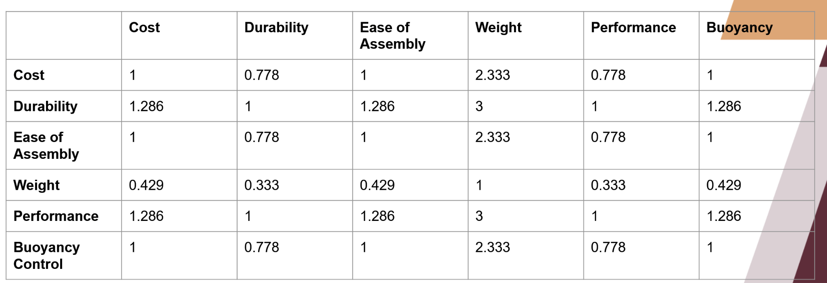
The calculated weights serve as the foundation for scoring design alternatives in the Analytical Hierarchy Process (AHP).
Table 6: Pairwise Comparison Chart

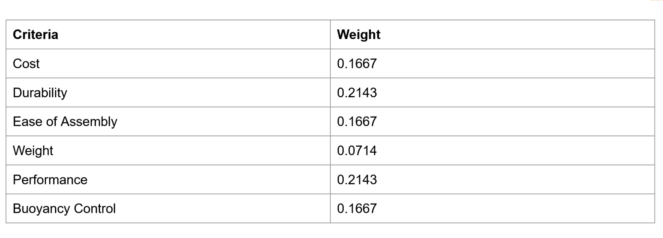
Table 7: Pairwise comparison (Criteria weights)

Analytical Hierarchy Process
In Table 8: AHP Table, it scores the three design alternatives (PVC Hull, PVC Frame, and Submarine Style) against the weighted criteria derived from the pairwise comparison. Each design is evaluated based on how well it satisfies the individual criteria:
- PVC Hull (0.420): Achieves the highest score, showing strong alignment with the project’s priorities. It excels in durability, cost, ease of assembly, and buoyancy control, making it the best choice for an affordable and educational kit. Its lower score in weight is outweighed by its strengths in more impactful criteria.
- PVC Frame (0.340): Ranks second, with its lightweight design being its primary strength. However, it underperforms in durability, cost, and performance, which are critical for the project.
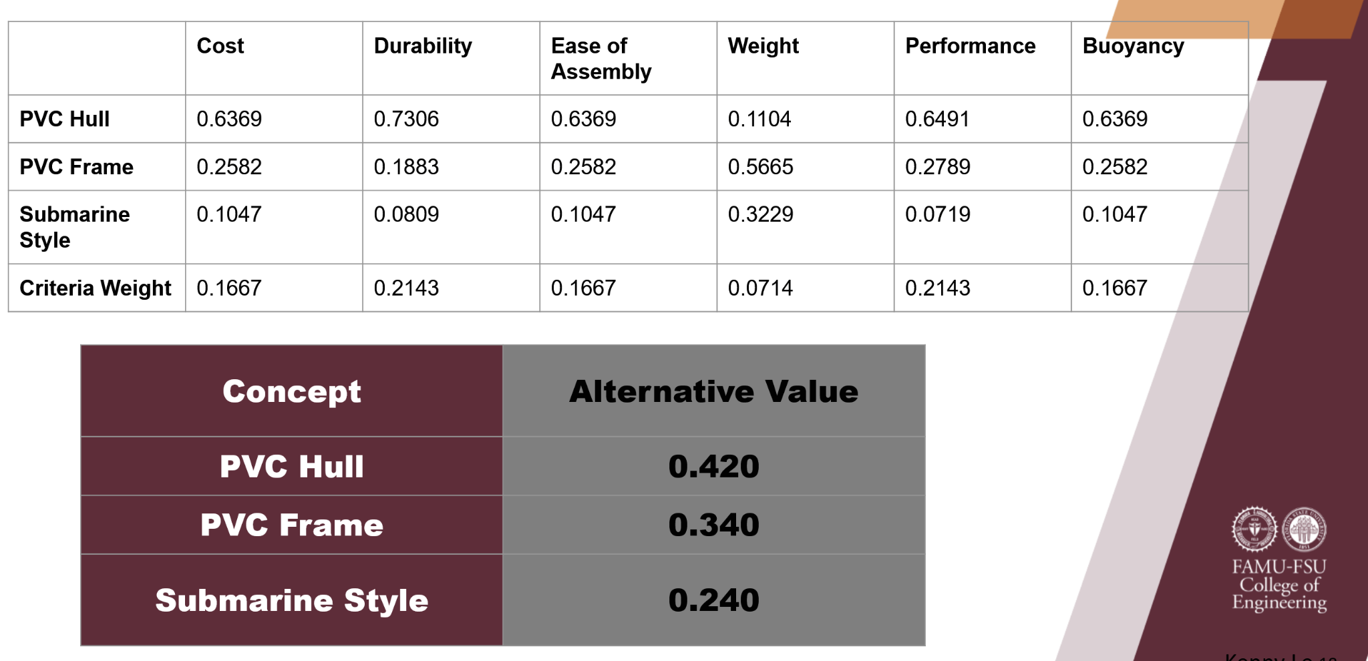
- Submarine Style (0.240): Scores the lowest, reflecting significant weaknesses in durability, performance, and ease of assembly. Its moderate score in weight does not compensate for these shortcomings, making it the least viable option.
Table 8: Analytical Hierarchy Process (AHP)
Final Selection
Our final concept should be one that best balances performance, cost, ease of use, and reliability while also meeting all the requirements identified in the House of Quality. From AHP, it is clear that the PVC Hull design (Column 1) should be the concept of choice. With focus during design being on waterproof up to 20 feet, being faster and more maneuverable than the Sea Perch Kit, and providing live camera feedback to the control station from the submersible. This means having an acrylic dome that is waterproof sealed to the end of a PVC pipe for the camera. Combined with powerful propellers integrated with XRP controller boards. All of which will be controlled and powered by a tether that runs to a control station on land where the user can view feedback and control the submersible using a video game controller.
Conclusion
During our concept selection process we used the House of Quality, Pugh Chart, and AHP to help us gain further insight on our concepts and requirements for our project. From this we were able to give numerical values and visualization to our options, allowing easy understanding of what needed to be prioritized during our design process and what concepts would best work for our customer needs and requirements. Aligning our design process with the customers needs. Our final selection becomes clear and we are going with the waterproof PVC hull design with acrylic dome and upgraded propellers to hit the target of live camera feed and being faster than the Sea Perch Kits while also being able to withstand depths of 20 feet.
1.8 Preliminary Design
Introduction
Problem Statement
This project involves developing an accessible and affordable submersible vehicle kit aimed at providing middle and high school students with a hands-on learning experience. The vehicle will demonstrate core principles of underwater robotics, such as buoyancy control, stability, and propulsion, with real-world applications in STEM education. Designed as an educational tool, the vehicle will be able to operate in controlled freshwater environments and handle depths up to 20 feet.
Motivation
This project aims to engage students in STEM by enabling them to build and operate a submersible vehicle. By working with hands-on robotics, students can learn fundamental engineering and physics concepts and gain experience with feedback control systems and mechanical design.
Requirements
- Affordability: Target cost under $500.
- Control: Simple, game controller-operated movement.
- Depth Capability: Operate at a maximum of 20 feet depth.
- Buoyancy Control: Neutral buoyancy and stability for underwater maneuverability.
- Live Feed: Real-time video camera feed accessible from the surface.
- Power Supply: Operate via tethered power for continuous use.

Selected Concept
The chosen concept for this submersible vehicle design is the PVC Hull Design. This design features a cylindrical PVC pipe structure with an acrylic dome housing the camera at the front, ensuring clear visibility underwater. Thrusters positioned at the rear and sides provide forward, backward, and depth control. The electronic components, including the controller board, are housed within the PVC hull to protect against water exposure. The tether, connecting the submersible to the control station onshore, carries both power and data, offering both control and video feed transmission.

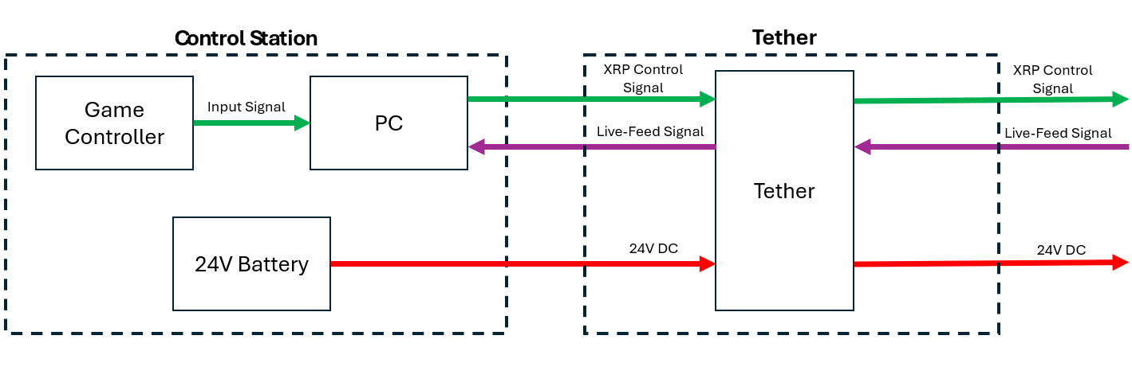
Figure 4: Submersible Vehicle System Diagram
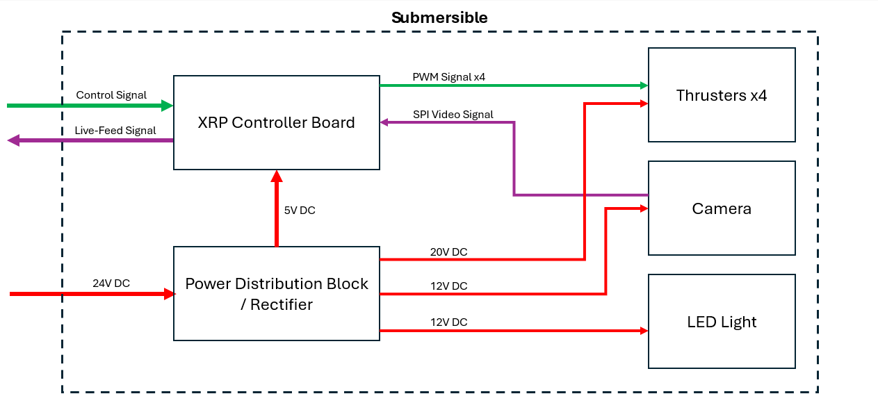
The block diagram above (Figure 4) shows the interactions of each component in the submersible vehicle system. Each box represents an individual component with the arrows connecting them representing inputs and outputs of each component. The block diagram closely mirrors our functional decomposition but focuses on component interaction rather than functions. One change from our functional decomposition is the addition of an LED light to be used for illumination while the vehicle is submerged.
Summary

The preliminary design for the submersible vehicle provides a robust foundation, outlining the interaction between system components and their roles. By integrating a controller board, thrusters, and camera within a PVC hull, the design allows for durability, ease of use, and cost-efficiency. The block diagram and component specifications set clear guidelines for the subsequent detailed design phase, where component selection and functional implementation will be finalized. This system’s engineering approach ensures all components will be successfully integrated in the final design to meet all requirements, from affordable construction to underwater stability and control.

1.9 Bill of Materials
The Bill of Materials (BOM) for the submersible vehicle kit demonstrates a cost-effective and functional approach to achieving project goals. It includes components for control, power, structure, communication, and assembly, carefully selected to balance affordability, durability, and performance. The use of PVC as the primary structural material highlights a focus on simplicity and accessibility, while essential electronics such as thrusters, a controller board, and a tether ensure reliable operation.
Assembly aids like primers, cement, and epoxy support robust construction, and optional features such as lighting and a waterproof camera enhance functionality. While the estimated cost for the kit remains within the $500 target, certain high-cost items, like the control computer, are excluded from the calculation. Overall, the BOM reflects thoughtful planning to align with the educational and technical requirements of the submersible vehicle project.

Table 9: Bill of Materials

 | Part Name | Description | Quantity | Unit Cost (USD) | Supplier | Notes | Did it Arrive?
Electronics | Xbox One Controller (Wireless) | Standard wireless game controller. | 1 | $39.99 | Walmart | N/A | No
Electronics | Computer (PC) | Windows laptop with USB interface. | 1 | $500-$1000 | Dell/HP/Lenovo | Must be compatible with control software. Cost omitted from kit cost. | No
Electronics | Power Supply | DC Power Supply, 24V 33A 880W, regulated output. | 1 | $120.00 | Amazon | May be switched with battery for final design. | No
Electronics | Tether | 40 ft, 14/2 Romex & CAT 6 Ethernet Cable | 1 | $50.00 | Amazon/Home Depot/Lowes | Power and communication lines will be combined into one tether. | No
Electronics | XRP Controller Board | SparkFun XRP Microcontroller board | 3 | $49.95 | SparkFun | Some have been supplied by the project sponsor. | No
Electronics | Power Distribution Block | High-current power distribution block. | 2 | $25.00 | Amazon | Will be used to distribute power at different voltages. | No
Electronics | LED Lights | Waterproof LED light strips | 2 | $10.00 | Amazon | Illumination for underwater use. | No
Electronics | Thrusters | Apisqueen U01 Brushless Thrusters and ESCs | 4 | $39.99 | Amazon | Includes Electronic Speed Controllers | No
Frame and Structural Components | PVC Ballast Skids | Charlotte Pipe 1-1/2-in x 10-ft 330 Psi Schedule 40 PVC Pipe | 2 | $1.28/foot length | Lowes (Charlotte Pipe) | PVC piping for buoyancy and skids. | No
Frame and Structural Components | PVC Ballast Skid Caps | 1-1/2 in. PVC Socket Schedule 40 Pressure Cap | 4 | $2.11/unit | Home Depot (Charlotte Pipe) | End fitting for Ballast Skids, does not have to be as watertight as hull caps. | No
Frame and Structural Components | PVC Hull Cap | 8 in. PVC Schedule 40 Socket Cap | 2 | $39.87/unit | Home Depot (Charlotte Pipe) | Must be installed using primer and solvent cementing. | No
Frame and Structural Components | PVC Hull (MAYBE ALUMINUM ACCORDING TO MCCONOMY!!!) | Schedule 40, 8 inch diameter, PVC piping for the submersible hull. | 1 | $69.99/foot length | The City Supplier (Ebay) | Schedule 40 8 inch diameter PVC can handle up to 180 PSI. At 20 feet depth pressure is about 8.86 PSI. | No
Camera and Accessories | Camera | SPI Camera, Waterproof | 1 | $36.99 | getfpv.com | IP67 rating | No
Assembly Materials | PVC Primer | 16 oz. Purple CPVC and PVC Primer | 1 | $9.27 | Home Depot (Oatey) | Environmentally friendly at low VOC levels. | No
Assembly Materials | PVC Cement | 16 oz. Heavy-Duty Clear PVC Cement | 1 | $15.48 | Home Depot (Oatey) | Used in pressure pipe applications. | No
Assembly Materials | Waterweld Epoxy | 2 oz. Waterweld Epoxy | 2 | $7.48/unit | Home Depot (JB WELD) | Lap Shear strength of 1300 PSI, specific for PVC and water applications. | No

Chapter Two: EEL 4914C/4915C

2.1 Risk Assessment
INTRODUCTION
University laboratories are not without safety hazards. Those circumstances or conditions that might go wrong must be predicted and reasonable control methods must be determined to prevent incident and injury. The FAMU-FSU College of Engineering is committed to achieving and maintaining safety in all levels of work activities.
PROJECT HAZARD ASSESSMENT POLICY
Principal investigator (PI)/instructor are responsible and accountable for safety in the research and teaching laboratory. Prior to starting an experiment, laboratory workers must conduct a project hazard assessment (PHA) to identify health, environmental and property hazards and the proper control methods to eliminate, reduce or control those hazards. PI/instructor must review, approve, and sign the written PHA and provide the identified hazard control measures. PI/instructor continually monitor projects to ensure proper controls and safety measures are available, implemented, and followed. PI/instructor are required to reevaluate a project anytime there is a change in scope or scale of a project and at least annually after the initial review.
PROJECT HAZARD ASSESSMENT PROCEDURES
It is FAMU-FSU College of Engineering policy to implement followings:
- Laboratory workers (i.e. graduate students, undergraduate students, postdoctoral, volunteers, etc.) performing a research in FAMU-FSU College of Engineering are required to conduct PHA prior to commencement of an experiment or any project change in order to identify existing or potential hazards and to determine proper measures to control those hazards.
- PI/instructor must review, approve and sign the written PHA.
- PI/instructor must ensure all the control methods identified in PHA are available and implemented in the laboratory.
- In the event laboratory personnel are not following the safety precautions, PI/instructor must take firm actions (e.g. stop the work, set a meeting to discuss potential hazards and consequences, ask personnel to review the safety rules, etc.) to clarify the safety expectations.
- PI/instructor must document all the incidents/accidents happened in the laboratory along with the PHA document to ensure that PHA is reviewed/modified to prevent reoccurrence. In the event of PHA modification a revision number should be given to the PHA, so project members know the latest PHA revision they should follow.
- PI/instructor must ensure that those findings in PHA are communicated with other students working in the same laboratory (affected users).
- PI/instructor must ensure that approved methods and precautions are being followed by :
  - Performing periodic laboratory visits to prevent the development of unsafe practice.
  - Quick reviewing of the safety rules and precautions in the laboratory members meetings.
  - Assigning a safety representative to assist in implementing the expectations.
  - Etc.
- A copy of this PHA must be kept in a binder inside the laboratory or PI/instructor’s office (if experiment steps are confidential).

Project Hazard Assessment Worksheet
PI/instructor: Dr. Chuy | Phone #: | Dept.: | Start Date: | Revision number: 1
Project: 310 - NSWC Submersible Vehicle Kit |  |  | Location(s):
Team member(s): Yili Liu, Riley Lessard, Parker Nuzum, Scott Garner, Justin Llerena, Kenny Le |  |  | Phone #: | Email:

Experiment Steps | Location | Person assigned | Identify hazards or potential failure points | Control method | PPE | List proper method of hazardous waste disposal, if any. | Residual Risk | Specific rules based on the residual risk
Assembly of submersible vehicle / PVC hull for prototyping. | ME Senior Design Workshop | Yili Liu and Riley Lessard | Glue/Epoxy vapor inhalation, skin contact, eye contact, ingestion, and repeated exposure. | Protective equipment and proper application and curing of glues and epoxies. | N95 respirator, nitrile gloves, eye protection. | Allow excess glue to fully dry in the container, then throw the container in regular trash. | HAZARD:1  CONSEQ:  Minor | Always wear gloves and safety glasses
 |  |  |  |  |  |  | Residual:  Low | Always wear gloves and safety glasses
Waterproofing Testing | Pool | Whole Team | Drowning, Electrocution, Glue/Epoxy contamination? | Pre Checks for electrical current leaks and proper curing of glues and epoxy. |  | N/A | HAZARD: 1  CONSEQ:  Significant | Only use a pool with a lifeguard on duty.
 |  |  |  |  |  |  | Residual:  Low Med | Only use a pool with a lifeguard on duty.
Operation of Vehicle | Pool | Whole Team | Lifting, Dropping Vehicle, Tripping or Entanglement on the Tether | Hi-Viz Tape on Tether | Close- Toed shoes | N/A | HAZARD:1  CONSEQ:  Moderate | Always lift the vehicle with two hands OR if >40 lbs two people required. Only use pool with lifeguard on duty.
Residual:
Low Med
Fabrication of Parts | ME Senior Design Workshop | Yili Liu, Riley Lessard and Scott Garner | Use of tools / power tools: cutting, smashing, pinching, eyes etc. | Stabilize all material being processed with a power tool | Gloves, Closed Toed Shoes,  Safety  Glasses | N/A | HAZARD:2  CONSEQ:  Significant | A team member must supervise the operation of power tools at all times ensuring safe operation.

Soldering | ME  Senior Design  Workshop | Whole Team | Burns, Inhalation of Fumes | Fume Hood / Extractor | Safety Glasses, Gloves | If lead solder is used, place waste in a plastic container and dispose of properly. | HAZARD:1  CONSEQ:  Minor | Always use fume extractor when soldering.
 |  |  |  |  |  |  | Residual: Low | Always use fume extractor when soldering.

Principal investigator(s)/ instructor PHA: I have reviewed and approved the PHA worksheet.
Name | Signature | Date | Name | Signature | Date
_______________________ | _________________ | ____________ | _______________________ | ________________ | ________
Team members: I certify that I have reviewed the PHA worksheet, am aware of the hazards, and will ensure the control measures are followed.
Name | Signature | Date | Name | Signature | Date
Riley Lessard | Riley Lessard | 12 NOV 24 | Justin Llerena | Justin Llerena | 12 NOV 24
Parker Nuzum | Parker Nuzum | 12 NOV 24 | Scott Garner Jr | Scott Garner | 12 NOV 24
Kenny Le | Kenny Le | 12 NOV 24 | Yili Liu | Yili Liu | 12 NOV 24

DEFINITIONS:
Hazard: Any situation, object, or behavior that exists, or that can potentially cause ill health, injury, loss or property damage e.g. electricity, chemicals, biohazard materials, sharp objects, noise, wet floor, etc. OSHA defines hazards as “any source of potential damage, harm or adverse health effects on something or someone". A list of hazard types and examples are provided in appendix A.
Hazard control: Hazard control refers to workplace measures to eliminate/minimize adverse health effects, injury, loss, and property damage. Hazard control practices are often categorized into following three groups (priority as listed):
- Engineering control: physical modifications to a process, equipment, or installation of a barrier into a system to minimize worker exposure to a hazard. Examples are ventilation (fume hood, biological safety cabinet), containment (glove box, sealed containers, barriers), substitution/elimination (consider less hazardous alternative materials), process controls (safety valves, gauges, temperature sensor, regulators, alarms, monitors, electrical grounding and bonding), etc.
- Administrative control: changes in work procedures to reduce exposure and mitigate hazards. Examples are reducing scale of process (micro-scale experiments), reducing time of personal exposure to process, providing training on proper techniques, writing safety policies, supervision, requesting experts to perform the task, etc.
- Personal protective equipment (PPE): equipment worn to minimize exposure to hazards. Examples are gloves, safety glasses, goggles, steel toe shoes, earplugs or muffs, hard hats, respirators, vests, full body suits, laboratory coats, etc.
Team member(s): Everyone who works on the project (i.e. grads, undergrads, postdocs, etc.). The primary contact must be listed first and provide a phone number and email for contact.
Safety representative: Each laboratory is encouraged to have a safety representative, preferably a graduate student, in order to facilitate the implementation of the safety expectations in the laboratory. Duties include (but are not limited to):
- Act as a point of contact between the laboratory members and the college safety committee members.
- Ensure laboratory members are following the safety rules.
- Conduct periodic safety inspection of the laboratory.
- Schedule laboratory clean up dates with the laboratory members.
- Request for hazardous waste pick up.
Residual risk: Residual Risk Assessment Matrix are used to determine project’s risk level. The hazard assessment matrix (table 1) and the residual risk assessment matrix (table2) are used to identify the residual risk category.
The instructions to use hazard assessment matrix (table 1) are listed below:
- Define the workers familiarity level to perform the task and the complexity of the task.
- Find the value associated with familiarity/complexity (1 – 5) and enter value next to: HAZARD on the PHA worksheet.

Table 1. Hazard assessment matrix.

 |  | Complexity
 |  | Simple | Moderate | Difficult
Familiarity Level | Very Familiar | 1 | 2 | 3
Familiarity Level | Somewhat Familiar | 2 | 3 | 4
Familiarity Level | Unfamiliar | 3 | 4 | 5

The instructions to use residual risk assessment matrix (table 2) are listed below:
- Identify the row associated with the familiarity/complexity value (1 – 5).
- Identify the consequences and enter value next to: CONSEQ on the PHA worksheet. Consequences are determined by defining what would happen in a worst case scenario if controls fail.
  - Negligible: minor injury resulting in basic first aid treatment that can be provided on site.
  - Minor: minor injury resulting in advanced first aid treatment administered by a physician.
  - Moderate: injuries that require treatment above first aid but do not require hospitalization.
  - Significant: severe injuries requiring hospitalization.
  - Severe: death or permanent disability.
- Find the residual risk value associated with assessed hazard/consequences: Low –Low Med – Med– Med High – High.
- Enter value next to: RESIDUAL on the PHA worksheet.
Table 2. Residual risk assessment matrix.
Assessed Hazard Level | Consequences
Assessed Hazard Level | Negligible | Minor | Moderate | Significant | Severe
5 | Low Med | Medium | Med High | High | High
4 | Low | Low Med | Medium | Med High | High
3 | Low | Low Med | Medium | Med High | Med High
2 | Low | Low Med | Low Med | Medium | Medium
1 | Low | Low | Low Med | Low Med | Medium

Specific rules for each category of the residual risk:
Low:
- Safety controls are planned by both the worker and supervisor.
- Proceed with supervisor authorization.
Low Med:
- Safety controls are planned by both the worker and supervisor.
- A second worker must be in place before work can proceed (buddy system).
- Proceed with supervisor authorization.
Med:
- After approval by the PI, a copy must be sent to the Safety Committee.
- A written Project Hazard Control is required and must be approved by the PI before proceeding. A copy must be sent to the Safety Committee.
- A second worker must be in place before work can proceed (buddy system).
- Limit the number of authorized workers in the hazard area.
Med High:
- After approval by the PI, the Safety Committee and/or EHS must review and approve the completed PHA.
- A written Project Hazard Control is required and must be approved by the PI and the Safety Committee before proceeding.
- Two qualified workers must be in place before work can proceed.
- Limit the number of authorized workers in the hazard area.
High:
- The activity will not be performed. The activity must be redesigned to fall in a lower hazard category.

Project Hazard Control- For Projects with Medium and Higher Risks
Name of Project:  Development of Submersible Vehicle Kit |  |  |  | Date of submission: 11/15/24
Team member |  | Phone number |  | e-mail
Justin Llerena |  | 305-416-8468 |  | jl20t@fsu.edu
Kenny Le |  | 904-236-0562 |  | knl19d@fsu.edu
Parker Nuzum |  | 561-779-3184 |  | Prn21@fsu.edu
Scott Garner |  | 850-524-9996 |  | scg21i@fsu.edu
Riley Lessard |  | 386-689-7404 |  | rjl20b@fsu.edu
Yili Liu |  | 448-229-3787 |  | yxl20@fsu.edu
Faculty mentor |  | Phone number |  | e-mail
Dr. Chuy |  | 850-410-6468 |  | chuy@eng.famu.fsu.edu
Dr. Noroozi |  | 850-410-6464 |  | bnoroozi@eng.famu.fsu.edu
Rewrite the project steps to include all safety measures taken for each step or combination of steps. Be specific (don’t just state “be careful”).
Gather Materials and Equipment
- Safety Measures: Wear safety gloves to protect against sharp edges and any potentially hazardous materials. Ensure all tools are inspected and in good condition before use.
Assemble the Frame
- Safety Measures: Use safety goggles to protect eyes from debris or accidental tool slips. Keep hands away from moving parts while using power tools, and secure the frame on a stable workbench to prevent shifting.
Install Electronic Components
- Safety Measures: Disconnect the power source when installing or handling electronic components to avoid electrical shock. Use anti-static wristbands to protect sensitive electronics from static discharge.
Waterproof the Hull
- Safety Measures: Wear a mask and gloves when handling sealant to avoid skin and respiratory exposure to chemicals. Ensure proper ventilation when working with adhesives or sealants to prevent inhalation of fumes.
Attach Propulsion System (Motors and Propellers)
- Safety Measures: Use protective gloves to avoid cuts from propeller edges. Keep hands and clothing away from propellers and moving parts to avoid injuries when testing propulsion.
Secure the Tether for Power and Control
- Safety Measures: Use cable ties to prevent loose wires that could cause tripping hazards. Ensure connectors are firmly in place and avoid connecting to a power source until testing begins.

Test Submersible in Shallow Water
- Safety Measures: Have an emergency plan in place for electrical issues in water. Use waterproof gloves when handling the submersible in water, and keep all power sources on a dry surface away from the test area to prevent electrical hazards.
Adjust Buoyancy and Balance
- Safety Measures: Use gloves when handling weights to protect hands from pinches or sharp edges. Make adjustments slowly and carefully to avoid sudden shifts in weight that could destabilize the vehicle.
Perform Final Operational Check
- Safety Measures: Perform this check in a dry area first to verify all controls and power functions. Ensure all team members are aware of emergency procedures in case of malfunction.
Run Full Submersion Test
- Safety Measures: Ensure the test area is supervised and has an emergency shut-off switch. Only one team member should handle the control to minimize risks, while others observe from a safe distance.

Thinking about the accidents that have occurred or that you have identified as a risk, describe emergency response procedures to use.

Emergency Response Procedures
- Electric Shock
  - Response: Immediately disconnect the power source. Do not touch the person if they are still in contact with the power supply. Call emergency services if needed. Administer first aid (CPR if trained) and seek medical attention for the affected individual.
- Chemical Exposure (e.g., from sealants or adhesives)
  - Response: Move the affected person to fresh air if they have inhaled fumes. If the chemical is on the skin, rinse thoroughly with water for at least 15 minutes. In case of eye contact, flush eyes with water for 15 minutes and seek medical help if irritation persists.
- Cuts or Puncture Wounds (from sharp tools or parts)
  - Response: Apply pressure to control bleeding and clean the wound with antiseptic. Use a sterile bandage to cover the wound. Seek medical attention if the cut is deep or if there is a risk of infection.
- Drowning or Water-Related Emergency During Testing
  - Response: If the submersible testing involves a water environment, ensure all team members can swim or have access to a life ring. In case of an emergency, retrieve the person from the water immediately, and administer CPR if necessary. Contact emergency services if the person shows signs of distress.
- Fire Hazard (from electrical components or batteries)
  - Response: Use a Class C fire extinguisher to put out small electrical fires. If the fire is large, evacuate the area and call emergency services. Do not use water on electrical fires as it can worsen the situation.
- Propeller or Motor Injury
  - Response: Immediately turn off power to the motors if someone is injured by moving parts. Provide first aid, clean the wound, and cover it with a sterile dressing. Seek medical attention if the injury is severe.
- Slip or Trip Hazard
  - Response: If someone falls or trips, assess for injuries. If they are able to move, help them up carefully. For serious injuries, avoid moving the person, call emergency services, and keep them comfortable until help arrives.

List emergency response contact information:
- Call 911 for injuries, fires or other emergency situations
- Call your department representative to report a facility concern
Name | Phone number |  | Faculty or other COE emergency contact |  | Phone number
 |  |  | Dr. Chuy |  | 850-410-6468
 |  |  | Dr. Hooker |  | 850-410-6463
 |  |  | Dr. Noroozi |  | 850-410-6464
 |  |  | Dr. Harvey |  | 850-410-6451

Safety review signatures
Team member | Date |  | Faculty mentor |  | Date
Justin Llerena | 11/15/24 |  | Dr. Chuy
Parker Nuzum | 11/15/24 |  | Dr. Chuy |  | 850-410-6468
Kenny Le | 11/15/24 |  | Dr. Chuy |  | 850-410-6468
 |  |  | Dr. Chuy |  | 850-410-6468
 |  |  | Dr. Chuy |  | 850-410-6468
 |  |  | Dr. Chuy |  | 850-410-6468
 |  |  | Dr. Chuy |  | 850-410-6468
Report all accidents and near misses to the faculty mentor.

2.2. Work Breakdown Structure

Introduction
Team 310, in partnership with NSWC Panama City, Sparkfun, and Experiential Robotics, aims to design and build an affordable and accessible submersible vehicle kit for educational purposes. This project is designed to promote STEM (Science, Technology, Engineering, and Math) learning among middle and high school students by offering hands-on experience with a submersible vehicle. The vehicle will be tethered, controlled via a game controller, and equipped with live video feedback, providing users with real-time control and monitoring capabilities. The primary focus is to ensure that the kit is affordable, costing no more than $500 (excluding R&D costs), while meeting key performance metrics such as depth, stability, and control precision. This work breakdown structure (WBS) organizes the necessary tasks and deliverables to guide the project from concept to final demonstration.

Team 310 Submersible Vehicle Kit: Work Breakdown Structure (WBS)

Major Deliverables
- Customer needs and interpreted needs (requirements)
- Functional decomposition
- Target specifications
- Virtual design review I (presentation)
- Concept generation
- Concept selection
- Preliminary detailed design
- Virtual design review II (presentation)
- Risk analysis
- Bill of materials
- Final detailed design
- Prototype development
- Testing and iteration
- System integration
- Final demo

WBS: Detailed Tasks and Sub-tasks

1. Customer Needs and Interpreted Needs (Requirements)
- 1.1: Conduct customer interviews
- Assignee: Scott Garner, Kenny Le, Riley Lessard, Justin Llerena, Yili Liu
- 1.2: Perform market research on submersible kits
- Assignee: Scott Garner, Riley Lessard, Yili Liu
- 1.3: Team discussion to refine customer needs
- Assignee: Parker Nuzum, Justin Llerena, Kenny Le
- 1.4: Translate customer needs into requirements
- Assignee: Scott Garner, Yili Liu
- 1.5: Document customer needs and interpreted requirements
- Assignee: Parker Nuzum, Justin Llerena
- 1.6: Proofread, revise, and submit document
- Assignee: Riley Lessard, Yili Liu, Scott Garner

2. Functional Decomposition
- 2.1: Break down vehicle systems into key components (hull, control system, tether, motors, etc.)
- Assignee: Riley Lessard, Scott Garner
- 2.2: Identify specific functionalities for each component
- Assignee: Justin Llerena, Yili Liu
- 2.3: Document the decomposition and submit document
- Assignee: Parker Nuzum, Kenny Le

3. Targets
- 3.1: Define performance metrics (e.g., depth, speed, stability)
- Assignee: Riley Lessard, Yili Liu
- 3.2: Align targets with project goals and market needs
- Assignee: Parker Nuzum, Justin Llerena
- 3.3: Set clear benchmarks for testing and evaluation
- Assignee: Scott Garner, Kenny Le
- 3.4: Document, proofread, revise, and submit document
- Riley Lessard, Scott Garner

4. Virtual Design Review I (Presentation)
- 4.1: Prepare presentation materials
- Assignee: Kenny Le, Justin Llerena
- 4.2: Review design concepts with sponsors and stakeholders
- Assignee: Riley Lessard, Scott Garner
- 4.3: Gather feedback for revisions
- Assignee: Parker Nuzum, Yili Liu
- 4.4: Document feedback and Presentations #1
- Assignee: Scott Garner, Kenny Le, Riley Lessard, Justin Llerena, Yili Liu, Parker Nuzum

5. Concept Generation
- 5.1: Brainstorm multiple design concepts
- Assignee: Scott Garner, Riley Lessard
- 5.2: Sketch and model initial ideas
- Assignee: Yili Liu, Parker Nuzum
- 5.3: Evaluate each concept’s feasibility
- Assignee: Justin Llerena, Kenny Le

6. Concept Selection
- 6.1: Compare concepts based on technical and market criteria
- Assignee: Riley Lessard, Kenny Le
- 6.2: Hold team discussions to select the best concept
- Assignee: Scott Garner, Riley Lessard, Parker Nuzum
- 6.3: Finalize the chosen concept
- Assignee: Justin Llerena, Riley Lessard
- 6.4: Document the selection process and submit
- Assignee: Scott Garner, Yili Liu

7. Preliminary Detailed Design
- 7.1: Create detailed CAD models for selected design
- Assignee: Yili Liu, Riley Lessard
- 7.2: Develop system block diagrams and schematics
- Assignee: Parker Nuzum, Kenny Le
- 7.3: Simulate key systems (control, buoyancy)
- Assignee: Scott Garner, Yili Liu
- 7.4: Document the design specifications
- Assignee: Justin Llerena, Kenny Le

8. Virtual Design Review II (Presentation)
- 8.1: Prepare updated design presentation
- Assignee: Kenny Le, Yili Liu
- 8.2: Present to stakeholders for final design review
- Assignee: Scott Garner, Kenny Le, Riley Lessard, Justin Llerena, Yili Liu, Parker Nuzum
- 8.3: Incorporate feedback into the final design
- Assignee: Scott Garner, Justin Llerena

9. Risk Analysis
- 9.1: Identify potential risks (technical, market, budget)
- Assignee: Parker Nuzum, Scott Garner
- 9.2: Perform risk assessment (likelihood, impact)
- Assignee: Riley Lessard, Kenny Le
- 9.3: Develop risk mitigation strategies
- Assignee: Yili Liu, Justin Llerena

10. Bill of Materials (BOM)
- 10.1: Compile a list of all required components
- Assignee: Kenny Le, Justin Llerena
- 10.2: Research costs and suppliers
- Assignee: Scott Garner, Yili Liu
- 10.3: Finalize the BOM for the prototype
- Assignee: Riley Lessard, Parker Nuzum

11. Final Detailed Design
- 11.1: Finalize CAD models and system schematics
- Assignee: Yili Liu, Scott Garner
- 11.2: Ensure designs meet all performance targets
- Assignee: Kenny Le, Riley Lessard
- 11.3: Write detailed design documentation
- Assignee: Parker Nuzum, Justin Llerena

12. Prototype Development
- 12.1: Order components based on the BOM
- Assignee: Parker Nuzum, Riley Lessard
- 12.2: Assemble the submersible vehicle
- Assignee: Yili Liu, Riley Lessard
- 12.3: Integrate electronics, control systems, and tether
- Assignee: Parker Nuzum, Kenny Le
- 12.4: Test the assembly for any major issues
- Assignee: Scott Garner, Yili Liu

13. Testing and Iteration
- 13.1: Develop a comprehensive testing plan (depth, control, camera feed)
- Assignee: Riley Lessard, Parker Nuzum, Kenny Le
- 13.2: Conduct pool tests and record data
- Assignee: Scott Garner, Justin Llerena
- 13.3: Analyze test results against performance targets
- Assignee: Yili Liu, Kenny Le
- 13.4: Revise design based on test results
- Assignee: Parker Nuzum, Riley Lessard
- 13.5: Document all iterations and test data
- Assignee: Scott Garner, Justin Llerena

14. System Integration
- 14.1: Integrate all subsystems (control, motors, camera feed)
- Assignee: Yili Liu, Riley Lessard
- 14.2: Perform end-to-end testing
- Assignee: Scott Garner, Kenny Le
- 14.3: Ensure all systems are functioning together seamlessly
- Assignee: Justin Llerena, Parker Nuzum
- 14.4: Make necessary adjustments based on testing
- Assignee: Parker Nuzum, Kenny Le

15. Final Demonstration
- 15.1: Prepare the submersible vehicle for demonstration
- Assignee: Riley Lessard, Parker Nuzum
- 15.2: Test all components for final demo (hardware and software)
- Assignee: Scott Garner, Yili Liu
- 15.3: Create demo presentation materials
- Assignee: Justin Llerena, Kenny Le
- 15.4: Perform the live demo for stakeholders
- Assignee: Scott Garner, Kenny Le, Riley Lessard, Justin Llerena, Yili Liu, Parker Nuzum

Results
The final submersible vehicle prototype performed as expected during initial testing. The propulsion system, including all four thrusters, responded accurately to user input from the topside control station, allowing for forward, backward, and vertical movement. The live video feed transmitted through the tether was stable and provided clear underwater visuals, confirming the successful integration of the waterproof camera system and communication lines.
The vehicle was able to reach and maintain operational depths close to 20 feet without major stability issues. Control responsiveness, maneuverability, and tether management all functioned within design expectations. Overall, the system met the key project goals of mobility, user control, and educational usability.
However, two minor performance challenges were observed during pool testing. First, while the vehicle achieved neutral buoyancy within an acceptable range, it occasionally exhibited slight upward or downward drift, indicating that fine adjustments to ballast placement or buoyancy control are needed for even better stability. Second, minor water leaks were detected around several cable penetrations, despite the use of O-rings and epoxy sealing. Future efforts will focus on refining these seals to ensure complete waterproof integrity during extended use.
Despite these small issues, the submersible proved reliable for demonstration purposes and provided a strong foundation for future educational kits.
Discussion
he testing phase demonstrated that the submersible vehicle met its primary objectives: stable maneuverability, live camera feedback, and affordability under $500. Small issues with buoyancy and waterproofing did not prevent successful operation but revealed areas for refinement. The slight buoyancy drift suggests that minor weight balancing adjustments are needed to achieve perfect neutral buoyancy. The small water leaks, although contained, highlighted the importance of improved sealing techniques at cable entry points. Overall, the design choices proved effective, and the educational goals of assembly, troubleshooting, and control were strongly supported through hands-on engagement with the system.
Conclusion
The Submersible Vehicle Kit project successfully achieved its mission of creating an affordable, durable, and educational underwater ROV for STEM outreach. By combining a robust PVC-based hull, a reliable tethered communication system, and a user-friendly control interface, the team delivered a platform that middle and high school students can use to explore underwater robotics concepts. The final prototype demonstrated strong performance in navigation, control responsiveness, and live video streaming during testing. Although minor improvements are needed to perfect buoyancy and waterproofing, the overall project met its technical, financial, and educational goals, laying a foundation for future use and expansion.
Future Works
Future development should focus on fine-tuning the ballast system to achieve perfectly neutral buoyancy without requiring manual adjustments. Improvements to cable penetrations, such as using custom-made bulkhead fittings or upgraded waterproof connectors, are recommended to eliminate minor leaks. Additional refinements could include developing a simplified assembly guide for students, enhancing software control for smoother motor ramping, and integrating a modular sensor bay for future STEM experiments. Expanding the kit’s documentation and creating tutorial videos would further enhance its educational value and ease of use for a wider audience.

Summary
The Work Breakdown Structure (WBS) for the Submersible Vehicle Kit project outlines the key tasks and milestones necessary for successful completion of the project. It begins with identifying customer needs, followed by functional decomposition, concept development, and design. Prototyping and testing ensure the vehicle meets performance targets, with revisions made as necessary. The WBS concludes with system integration and a final demonstration, ensuring the project delivers on its goals of affordability, performance, and educational impact. This structured breakdown ensures clarity in task assignment and efficient progress tracking, guiding the project from concept to completion.

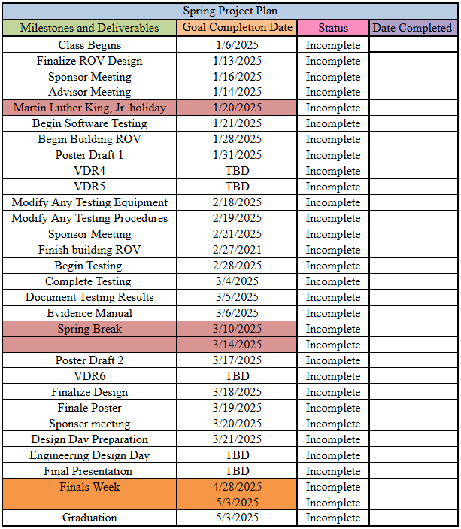
Table 10: Spring Schedule

Appendices

Appendix A: Code of Conduct

Mission Statement
The purpose of Team 310 is to collaboratively design an affordable, reliable, and educational submersible vehicle kit. Our mission is to create an innovative product that engages students with STEM concepts while meeting stakeholder needs. Team 310 values teamwork, integrity, inclusivity, and a commitment to delivering high-quality results. We strive to empower students through accessible and functional engineering solutions, reflecting our dedication to affordability, technical excellence, and educational impact.
Roles
Each team member is delegated a specific role based on their experience and skill sets and is responsible for all here-within:
Team Leader: Riley Lessard
Manages the team as a whole; develops a plan and timeline for the project, delegates tasks among group members according to their skill sets; finalizes all documents and provides input on other positions where needed. The team leader is responsible for promoting synergy and increased teamwork. If a problem arises, the team leader will act in the best interest of the project. He keeps the communication flowing, both between team members and Sponsor. The team leader takes the lead in organizing, planning, and setting up meetings. In addition, he is responsible for keeping a record of all correspondence between the group and ‘minutes’ for the meetings. Finally he gives or facilitates presentations by individual team members and is responsible for overall project plans and progress. In addition, he oversees team progress and ensures deliverables align with project goals.
Team members:
Financial Advisor: Justin Llerena
Manages the budget and maintains a record of all credits and debits to the project account. Any product or expenditure requests must be presented to the advisor, who is then responsible for reviewing and the analysis of equivalent/alternate solutions. They then relay the information to the team and if the request is granted, order the selection. A record of these analyses and budget adjustments must be kept. Responsible for power management and controller integration.
Lead ME: Yili Liu
Takes charge of the mechanical design aspects of the project. Keeps line of communication with the lead ECE. He is responsible for knowing details of the design, and presenting the options for each aspect to the team for the decision process. Keeps all design documentation for record and is responsible for gathering all reports. Designs structural components and manages buoyancy systems. Designs structural components and manages buoyancy systems.
Lead ECE: Parker Nuzum
He is responsible for the EE or CE design part in support of the project. He maintains a line of communication with the lead ME. He Keeps all design documentation for record. Develops control algorithms and interfaces for the topside control station.

Floater: Scott Garner, Kenny Le
Responsible for the overall development of all project tasks. Ensures design reliability through rigorous testing and analysis. Coordinates subsystem assembly and communication integration.
All Team Members:
- Work on specific tasks of the project
- Buys into the project goals and success
- Delivers on commitments
- Adopt team spirit
- Listen and contribute constructively (feedback)
- Be effective in trying to get message across
- Be open minded to others ideas
- Respect others roles and ideas
- Be ambassador to the outside world in own tasks
Communication
The main form of communication will be over phone and text-messaging among the group, preferably phone as well as through regular meetings of the whole team. Email will be a secondary form of communication for issues not being time-sensitive. For the passing of information, i.e. files and presentations, email will be the main form of file transfer and proliferation.
Each group member must have a working email for the purposes of communication and file transference. Members must check their emails at least twice a day to check for important information and updates from the group. Although members will be initially informed via a phone call, meeting dates and pertinent information from the sponsor will additionally be sent over email so it is very important that each group member checks their email frequently.
If a meeting must be canceled, an email must be sent to the group at least 24 hours in advance.
Any team member that cannot attend a meeting must give advance notice of 24 hours informing the group of his absence. Reason for absence will be appreciated but not required if personal. Repeated absences in violation with this agreement will not be tolerated.

Methods of Communication
- Scheduling: Weekly meetings will be held every Friday at 3 PM to review progress, assign tasks, and address challenges.
- Communication Tools: Primary communication through Slack and email; emergency updates will be handled via text messaging.
Team Dynamics
The students will work as a team while allowing one another to feel free to make any suggestions or constructive criticisms without fear of being ridiculed and/or embarrassed. If any member on this team finds a task to be too difficult it is expected that the member should ask for help from the other teammates. If any member of the team feels they are not being respected or taken seriously, that member must bring it to the attention of the team in order for the issue to be resolved. We shall not let emotions dictate our actions. Everything done is for the benefit of the project and together everyone achieves more. Attendance is mandatory for all team meetings. Members who miss a meeting without prior notice must review meeting minutes and discuss deliverables with the team lead. In cases of recurring absences, external advisors or sponsors will be informed for additional support.

Individual and Team Goals:
Each team member’s individual goals align with and support the team’s overall objectives:
- Riley Lessard: Ensure all deliverables are completed on schedule, reflecting the team’s commitment to timeliness and quality.
- Yili Liu: Guarantee structural integrity of the design, contributing to reliability and educational value.
- Justin Llerena: Provide efficient power management solutions that enhance affordability and functionality.
- Kenny Le: Ensure seamless integration of subsystems, supporting the project’s performance and accessibility goals.
- Parker Nuzum: Deliver user-friendly software for the control station to maximize educational utility.
- Scott Garner: Conduct rigorous testing to identify and address potential design flaws, ensuring reliability at depth.

Ethics
Team members are required to be familiar with the NSPE Engineering Code of ethics as they are responsible for their obligations to the public, the client, the employer, and the profession. There will be stringent following of the NSPE Engineering Code of Ethics.
Dress Code
Team meetings will be held in casual attire. Sponsor meetings and group presentations will be business casual to formal as decided by the team per the event.
Weekly and biweekly Tasks
Team members will participate in all meetings with the sponsor, adviser and instructor. During said times ideas, project progress, budget, conflicts, timelines and due dates will be discussed. In addition, tasks will be delegated to team members during these meetings. Repeat absences will not be tolerated.
Attendance Policy
Team members will participate in all meetings with the sponsor, adviser, and instructor. Attendance will be accounted for via the minutes sheet taken at each meeting. Three unexcused absences will result in the notification of the instructor to assist in remedial action.
Decision Making
It is conducted by consensus and majority of the team members. Should ethical/moral reasons be cited for dissenting reasons, then the ethics/morals shall be evaluated as a group and the majority will decide on the plan of action. Individuals with conflicts of interest should not participate in decision-making processes but do not need to announce said conflict. It is up to each individual to act ethically and for the interests of the group and the goals of the project. Achieving the goal of the project will be the top priority for each group member. Below are the steps to be followed for each decision-making process:
- Problem Definition – Define the problem and understand it. Discuss among the
group.
- Tentative Solutions – Brainstorms possible solutions. Discuss among groups most plausible.
- Data/History Gathering and Analyses – Gather necessary data required for implementing Tentative Solution. Re-evaluate Tentative Solution for plausibility and effectiveness.
- Design – Design the Tentative Solution product and construct it. Re-evaluate for plausibility and effectiveness.
- Test and Simulation/Observation – Test design for Tentative Solution and gather data. Re-evaluate for plausibility and effectiveness.
- Final Evaluation – Evaluate the testing phase and determine its level of success. Decide if design can be improved and if time/budget allows for it.
Conflict Resolution
In the event of discord amongst team members the following steps shall be respectfully employed:
- Communication of points of interest from both parties which may include demonstration of active listening by both parties through paraphrasing or other tools acknowledging clear understanding.
- Administration of a vote, if needed, favoring majority rule.
- Team Leader intervention.
- Instructor will facilitate the resolution of conflicts.
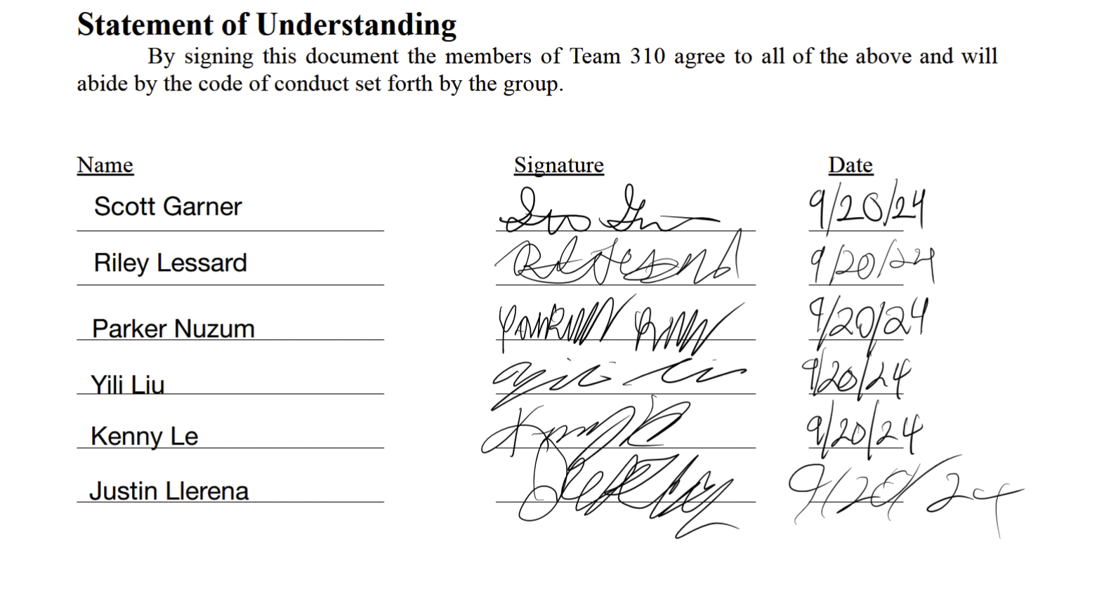

Appendix B: Functional Decomposition

Appendix C: Target Catalog
Target Catalog (Critical Targets Highlighted)

Function | Target | Metric
Regulate Heading | The submersible kit should maintain heading within 5 degrees of desired input heading from the controller. | degrees
Regulate Depth | The submersible kit should ascend or descend in accordance to the desired input from the controller. | feet/second
Capture Live Camera Feed | Provide live and HD visual feedback on a screen the operator can see. | 720p 30fps
Batteries/Power | Optimize energy usage / maximize run time. Targeting a run time of at least 20 minutes. | Watts (W) or Minutes
Maintain Neutral Buoyancy | Submersible vehicle depth while idle should not change by more than 3 inches in one minute. | inches/minute
Maintain Center of Mass | When submerged and idle, a submersible kit should not roll, pitch, or yaw by more than 5 degrees/min. | degree/min
Maintain Watertight Hull | The hull of the submersible kit should take on 0 ml/hr of water when submerged. | milliliter/hour (ml/hr)
Withstand Water Pressure | The submersible vehicle kit should be fully operational and take on no damage as a result of pressure at a depth of 20ft underwater. | feet (ft) [depth]
Thrust power | Provide quick acceleration and deceleration to allow vehicle to reach target speed rapidly | meters/second

Additional Targets

Description | Target | Metric
Vehicle Weight | Submersible should weigh less than 20 kilograms. | kg
Kit Packaging | The entire submersible vehicle kit (unassembled) should fit in a standard 20x18x12 inch shipping box. | inch
Data transmission | Ensure continuous communication for transmitting control signals from controller to vehicle over a 50ft tether | milliseconds
Automatic Surface Recovery | Ensure the vehicle can float back to the surface in case of failure or power loss | foot/second

Appendix D: Concept Generation
Forced Analogy
- Wings on back - Like a rocket ship.
- Propeller at front - Similar to an airplane’s.
- Propeller on top - Helicopter rotor.
- Propulsion mechanism - Recoil of a gun.
- Floating - Floats like a balloon.
- Slow sinking - Falls like a feather.
- Jet engine thrusters - Provides forward movement.
- Hot air balloon control - Buoyancy managed like altitude control in a balloon.
- Umbilical cord tether - Like a mother and baby connection.
- Wind turbine propellers - Generates movement through water.
- Fuel tank battery - Stores energy like a car’s fuel tank.
- Eye vision camera feed - Live camera feed mimicking human vision.
- Spacesuit pressure hull - Protects like a spacesuit in deep space.
- Steering wheel controller - Like controlling a car’s movement.
- Blood circulation signal transmission - Constant flow of signals, like blood in the body.
- Parachutist’s free fall - Achieving neutral buoyancy like terminal velocity.
- Airplane flight control - Pitch, roll, yaw just like an aircraft.
- Raincoat waterproofing - Submersible shielding similar to a raincoat.
- Deep-sea diving suit - Pressure-resistant, akin to diving suits.
- Internet bandwidth data transmission - Like fast internet for real-time data.
- Compass heading control - Guiding direction like a compass.
- Elevator depth control - Vertical movement similar to an elevator.
- Solar panel energy efficiency - Maximizing operation like solar panel use.
- Life jacket surface recovery - Floats back to the surface in case of failure.
- Ziploc watertight hull - Keeps water out like a Ziploc bag.
Crap Shoot
- Uncontrollable sinking - Submersible always sinks.
- Constant overheating - Vehicle fails from overheating instantly.
- Camera feed failure - Camera only shows static or no signal.
- No movement - Cannot move or change direction.
- Water leakage - Water seeps into the electronics.
- Assembly problems - Impossible to assemble or disassemble.
- Power consumption spike - Drains energy at the highest possible rate.
- Communication loss - Loses communication with the controller frequently.
- Instant breakage - Breaks upon light impact with any surface.
- Too heavy - Constantly crashes due to excess weight.
- Invisibility - Impossible to see during operation.
- Control failures - Ignores all user inputs.
- Uncontrollable spin - Vehicle spins wildly without stopping.
- Uncontrollable rising - Always shoots to the surface.
- Instant loss of buoyancy - Sinks the moment it's deployed.
- Corrosion - Prone to corrosion after single use.
- Tether tangling - Constantly tangled in its own tether.
- Inoperative underwater - Cannot function in water at all.
- Pressure vulnerability - No protection from water pressure.
- Noise pollution - Emits loud noise that disturbs marine life.
- Environmental sensitivity - Works only in perfect environmental conditions.
- No modularity - Completely non-modular, cannot be fixed easily.
- Complex controls - Controls are so complex only experts can operate.
- Rapid battery depletion - Loses all power when idle.
- Short tether - Tether is too short, limiting range significantly.
Anti-Problem
- Tinted dome - Camera can't see through super-tinted dome.
- Extra weight - Made from extremely heavy material.
- Power-hungry motors - Requires an absurd amount of power to function.
- Rigid tether - Supersensitive tether reduces mobility.
- Rare materials - Use of rare materials for no functional gain.
- Constant floating - Positively buoyant, always at the surface.
- Extreme complexity - Controls are overly complex, leading to confusion.
- Cost escalation - Uselessly expensive due to premium material use.
- Weak hull - Thin, fragile hull that breaks easily.
- Hard to repair - No possibility of repairs without specialist equipment.
- Poor buoyancy control - No ability to manage depth.
- Short battery life - The vehicle has an extremely short operational time.
- Slow speed - Moves at an excruciatingly slow speed.
- No propulsion - Propellers are underpowered.
- Irreversible design flaws - Major flaws that cannot be fixed after production.
- Leaking fuel cells - Vehicle leaks energy constantly.
- Sensitive to light - Malfunctions when exposed to direct sunlight.
- Unbalanced design - Tilts to one side uncontrollably.
- Overly fragile tether - Tether snaps easily, losing connection.
- Manual-only controls - No automated systems, everything is manual.
- Rust-prone parts - Parts rust easily, even in light moisture.
- Energy inefficient - Wastes energy, draining power too quickly.
- Always overheats - Motors overheat even under normal operation.
- Tiny view field - Camera offers a minuscule view.
- Unnecessarily large - Huge vehicle for minimal functionality.
Biomimicry
- Shark-like fins - Fins inspired by shark anatomy for streamlined movement.
- Fish fin control surfaces - Like fish fins for heading control.
- Fish-shaped hull - Streamlined, fish-like body for easier movement.
- Body movement propulsion - Movement propulsion like fish.
- Swim bladder buoyancy - Depth control akin to a fish’s swim bladder.
- Angler fish light source - Light protruding from the body to guide navigation.
- Membrane waterproofing - External membrane for waterproofing.
- Pressure resistance by design - Like deep-sea fish with internal air reduction.
- Fish scale movement control - Fish scale-like surface for enhanced movement.
- Mucus layer - Mucus-like covering to reduce drag in water.
- Grooved hull - Grooves on the hull to reduce drag, like fish.
- Electric field sensors - Sensors to detect nearby obstacles in low visibility.
- Fusiform body shape - A fusiform body for smooth movement through water.
- Duck-like flapping - Kicking flaps for propulsion like ducks.
- Seal-like body movement - Full body movement similar to a seal’s swimming.
- Low-light cameras - Camera system for dark underwater environments.
- Echolocation navigation - Use sonar/radar like dolphins.
- Pufferfish depth control - Hull shape changes for depth control, like a pufferfish.
- Jellyfish pulsating propulsion - Pulsating movement for thrust, like jellyfish.
- Squid-like jet propulsion - Rear propulsion similar to how squids move.
- Mucus coating for corrosion - Mucus-like covering to protect against corrosion.
- Self-cleaning camera dome - Camera dome similar to eye blinking to clean itself.
- Lobster antenna sensors - Antennas for close proximity object detection.
- Clam-like hard shell - Hard shell for protection, similar to clams or crabs.
- Legs for seafloor movement - Legs for movement along the ocean floor, like crabs.

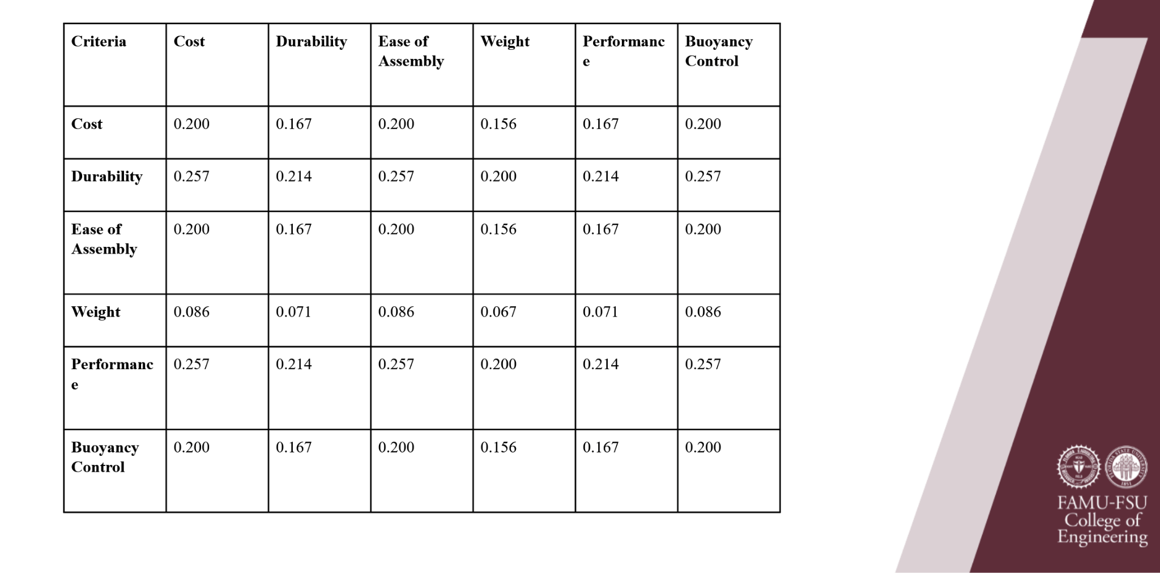
Appendix E: Concept Selection
Figure 1: Pairwise Comparison

Appendix F: Calculations
Appendix G: Scholarship in Practice
Yili Liu
Over the course of designing and manufacturing the submersible vehicle kit with team 310 for senior design, we made a plethora of mistakes and learned a lot in the process. I can genuinely say that this process has made me a better engineer and given me a new appreciation
for the design process and everything that engineers have been able to create thus far for humanity.
As the lead mechanical engineer for team 310, I was in charge of the body design and helped the other mechanical engineer, Riley Lessard, with waterproofing the hull. The body, which is 3D printed with PLA, went through multiple iterations. The first incorrect decision I made was designing the body without its manufacturing process in mind. The body was extremely unoptimized for 3D printing and required a lot of support material, resulting in long print times, poorly finished surfaces, and lots of wasted material. Through trial and error, the final design required significantly less time and resources to print. The solution was to account for the direction of print and make use of sloped geometry of at least 45 degrees to remove the need for supports and reduce overhangs. Through this process, I now know if I were to restart at the drawing board I would start the initial design with the manufacturing process and its limitations in mind, preventing bottlenecks down the road with trying to optimize a geometry that was initially designed with no regard to the manufacturing process. The second decision where we made a mistake was not validating our concepts and rushing through the testing. For the submersible hull, we used a 4 inch inner diameter PVC pipe along with two end caps that were waterproofed through a flange and two O-rings each. This concept is directly from BlueRobotics, a company that specializes in ROV parts and equipment. Their waterproof enclosures range between $300-$500 depending on the diameter and depth rating, their lowest tier is rated for 65 meters, almost 10 times deeper than our target waterproof depth. We recreated their design by 3D printing their flanges, buying their O-rings, and using our own PVC tube instead of their acrylic tube. We realized that it would not be as robust as their design due to the difference in material and tolerances, but we expected it to be at least 10% as effective. We were wrong. Even with 100% infill, epoxy coats, and multiple adjustments to the flange sizes, there were still small leaks at max depth. The PLA or PVC pipe also changed during use. The rear flange specifically was tight and waterproof during one test while the front leaked a little and after fixing the front, the rear flange became super loose on the next test. We theorized that the PLA may have shrunk as a result of heating from epoxy and then the cooling of the water, or water absorption, but we are not sure what happened for the fit to go from watertight to significantly looser. We obviously underestimated the variables and their effect on the performance of the watertight enclosure.
Through this design process we overcame many obstacles and learned a lot. The main two decisions that come to mind that I would go back and change are designing with manufacturing processes in mind and thorough validation of design.

Justin Llerena
Decision 1: Choosing a 4S 14.8V LiPo Battery as the Power Source
Early in the design process, our team selected a 4S 14.8V LiPo battery to power the submersible vehicle. We made this choice based on its common use in robotics kits, high energy density, and compatibility with our brushless thrusters.
Outcome:
While the battery provided reliable power during testing, we encountered challenges with balance, waterproofing, and safe charging practices. The battery’s size and placement affected weight distribution inside the hull, which caused initial instability during float testing. Additionally, we underestimated the learning curve for safely managing LiPo batteries.
Reflection:
Looking back, we might have opted for an external power supply during early prototyping or selected a lower-capacity battery to reduce weight. We also should have more thoroughly documented battery handling instructions for future users. This decision, while functional, exposed our team to unforeseen design trade-offs between power and usability.

Decision 2: Integrating the XRP Controller Board for All Control Logic
We decided to use the XRP controller board as our main processor for motor control and communication. Our intent was to simplify the system by relying on one board that supported multiple inputs (joystick, camera, PWM).
Outcome:
The XRP board worked well for basic control and PWM output, but it required additional development effort to integrate external libraries and lacked sufficient documentation for more complex tasks. We spent a significant amount of time debugging SPI communications for the camera and adapting code for thruster control.
Reflection:
Given more time, we might have separated the workload by pairing the XRP with a secondary microcontroller (e.g., Arduino or Pi Pico) for managing peripherals. This would have improved modularity and reduced risk of overloading one board. Our decision simplified hardware but created a bottleneck in software development.

Final Thoughts:
Both of these decisions reflect our desire to streamline the system. However, in hindsight, we learned that balancing simplicity with flexibility is critical in system-level design. If I were to repeat the project, I would involve more testing with alternate configurations earlier in the design cycle and seek more feedback from similar robotics projects.

Kenny Le
Throughout the development of the submersible vehicle kit, I was involved heavily in the software design and integration of the control system, sensor data acquisition, and telemetry display. One of the first major decisions I contributed to was the choice to use the XRP Beta Board as the central microcontroller for the system. Initially, this choice made sense—it was cost-effective, designed with education in mind, and offered native support for MicroPython, which streamlined development. However, as the project evolved, the limitations of the XRP board began to surface. Its processing capabilities proved to be insufficient when managing high-frequency tasks like real-time sensor polling, motor control, and serial communication simultaneously. This bottleneck became especially apparent when implementing features like live PID-controlled depth hold and streaming telemetry data to the dashboard. The issue was compounded by the fact that the XRP board shared the same USB interface for both program output and control data, preventing us from debugging in real-time during live tests. Looking back, I now recognize that it would have been more effective to separate responsibilities between the XRP and a more powerful processor such as the Raspberry Pi 4 from the very beginning. This would have allowed the XRP to handle low-level motor control and immediate sensor reads, while the Pi could manage higher-level tasks like GUI display, video feed processing, and telemetry management without overloading the system.
Another decision that stands out was our initial implementation of the depth-hold system using only a proportional (P) controller. The idea was to start simple and iterate—using a single gain value to push the sub up or down depending on its distance from the target depth. At first glance, this seemed like a practical way to quickly prototype the feature and observe system behavior. However, the limitations of this approach quickly became evident in real-world tests. The submersible frequently overshot the target depth or failed to maintain it within an acceptable margin, especially in the presence of sensor noise or buoyancy shifts. At that point, my teammate Scott Garner, who served as the testing engineer, played a crucial role in helping me analyze the PWM and sensor signals. Scott provided access to his lab equipment, including an oscilloscope, which allowed us to visually inspect the signal waveforms being sent to the thrusters. We analyzed the signal characteristics on the oscilloscope, and it became clear that a full PID controller would offer significantly better dynamic behavior. Once we upgraded to a full PID controller, the behavior of the sub improved dramatically. It stabilized around the target depth with far less oscillation. This experience taught me that while simplification can help during early development, some control systems—especially those involving physical dynamics—benefit greatly from being modeled more comprehensively from the start. In the future, I would advocate for either beginning with a full PID system or running simulations to guide tuning before implementation.
Overall, this project has given me a clearer understanding of how critical system architecture and control design are in real-world robotics applications. Several of the decisions we made early on were based on assumptions that did not hold up under testing. This forced us to revisit and revise key elements of the system multiple times. While this iterative process ultimately led to a more robust solution, it also highlighted the importance of early-stage planning, hardware-software partitioning, and testing under real conditions. By critiquing my own contributions and the decisions I supported, I’ve gained a deeper appreciation for thoughtful engineering and the need to continuously evaluate and adapt technical choices as a project progresses.

Parker Nuzum
Throughout the process of designing and building the submersible vehicle kit with Team 310 for our senior design project, we encountered countless challenges and learned a great deal along the way. Looking back, I can genuinely say this experience has made me a stronger engineer and deepened my appreciation for the engineering design process and the incredible innovations engineers have contributed to society.
As the lead Electrical and Computer Engineer (ECE) on our team, I was responsible for the electrical system and power management. My first task was to select the core components and identify suitable batteries to power them. We were given a target operational time of 30 minutes, and I’m proud to say we successfully doubled that time without exceeding our budget or space limitations.
After finalizing the components, I designed the power distribution system using a block diagram, then proceeded to create the necessary electrical connections to bring the system to life. I carefully translated this block diagram onto our electronics tray, configuring it to fit within the constraints of our vehicle’s housing. This required significant trial and error, as I tested numerous placement combinations to ensure everything could fit cohesively inside the enclosure.
One notable mistake I made was during the creation of the waterproof connections that extended outside of the watertight hull. I placed the heat-shrink tubing too close to my soldering points, and by the time I completed the soldering, the tubing had prematurely shrunk in place, rendering it unusable and requiring a redo.
Despite the setbacks, this project was filled with valuable learning moments. If I had the chance to go back and improve two aspects of our design approach, they would be: first, incorporating manufacturing constraints more deliberately into the initial design; and second, performing more thorough validation of our systems early on. These lessons are ones I’ll carry forward in future projects.

Appendix H: Operation Manual: NSWC - T310 Submersible Vehicle Kit

Yili Liu, Riley Lessard, Parker Nuzum, Scott Garner, Kenny Le, Justin Llerena
FAMU-FSU College of Engineering
EML4552C/EEL4914C: Senior Design II
Dr. Shayne McConomy, Dr. Oscar Chuy
April 18, 2025

Project Overview
This project is a submersible vehicle kit made in partnership with the Naval Surface Warfare Center of Panama City Division, the goal of this project is to provide an affordable kit that educational programs 6-12th grade can use to educate students on STEM topics such as buoyancy, electrical wiring, control, etc. The final assembled submersible will be able to operate at depths of 20 feet, be controlled through a video game controller, and provide live video feedback to an onland control station. All this will be available at a cost of under 500 dollars.

Component/Module Description
Submersible Outer Body

Rear body piece
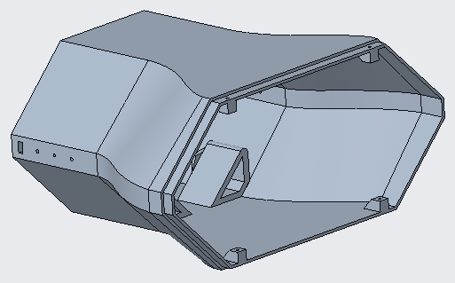
  - Printed using PLA on a 3D Printer (Preferably Prusa XL).
  - Mounts two APISQUEEN U01 underwater thrusters (lateral) using screws.
  - 4 screw points for front body pieces using M3x10mm self tapping screws.
  - 2 screw points for endcap using M3x10mm self tapping screws.

Front lower body piece
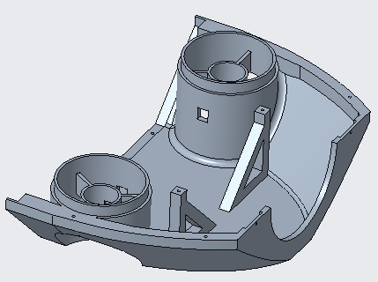
  - Printed using PLA on a 3D Printer (Preferably Prusa XL).
  - Mounts two APISQUEEN U01 underwater thrusters (vertical) using screws.
  - Clamping points for waterproof hull, using 2 M3x14mm self tapping screws.
  - 8 total screw holes for assembling the rear and front upper body piece, using M3x10mm self tapping screws.

Front upper body piece
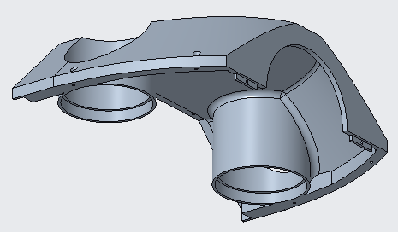
  - Printed using PLA on a 3D Printer (Preferably Prusa XL).
  - 8 total screw holes for assembling the rear and front upper body piece, using M3x10mm self tapping screws.

Endcap
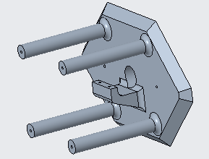
  - Printed using PLA on a 3D Printer (Preferably Prusa XL).
  - Fits up to 40 cm total length of buoyancy foam (pool noodles).
  - Clamping points for tether, using 2 M3x10mm self tapping screws.
  - 2 M3x10mm screws for mounting to the rear body piece.

Clamp
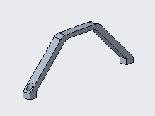
  - Printed using PLA on a 3D Printer (Preferably Prusa XL).
  - Clamps onto the front lower body piece using 2 M3x14mm screws to hold the waterproof hull in place.

Power and Data:
- Schematic
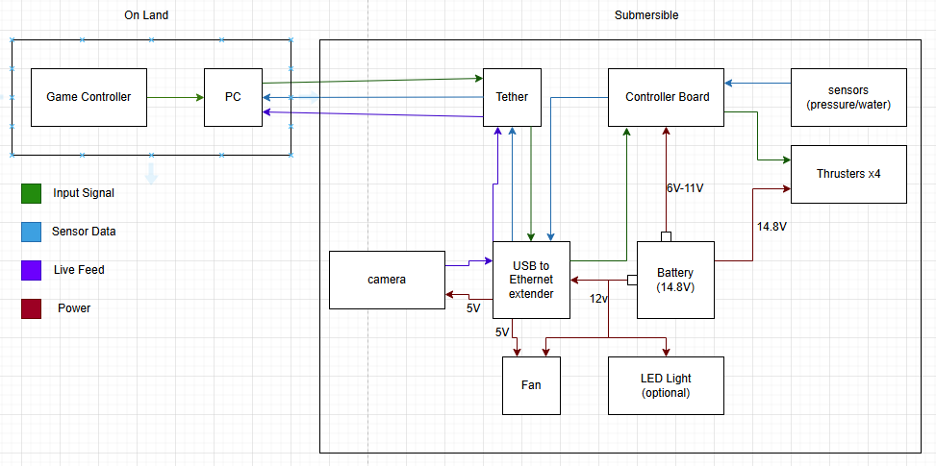
  - 2 Main Blocks
    - On Land(Game Controller,Pc,Tether)
    - Submersible(Tether,Usb to Ethernet,Camera,Controller Board,thrusters,sensors,LED Light,Fan)
    - Small Squares (Buck converter)
- Power System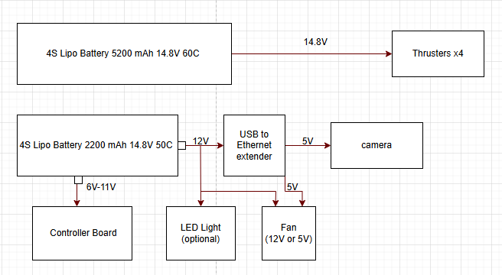
  - 2 Batteries
    - 14.8V
    - 5200mAh,60C (4 Thrusters,Voltameter)
    - 2200mAH,50C (Controller Board, USB to Ethernet extender, LED Light, Fan 12V or 5V)

- Breakdown (60C)
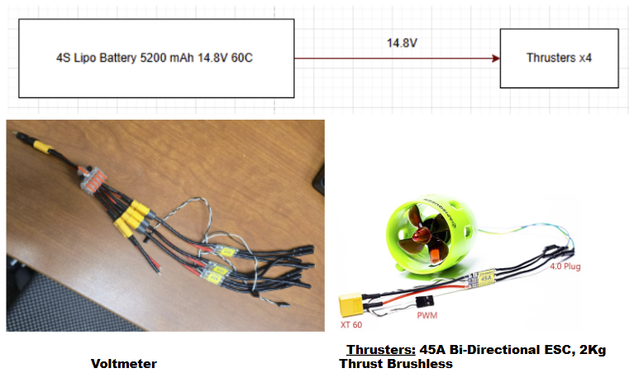
- 1 to 5 power connection
  - 4 Thrusters
  - Voltameter
- Runtime
  - 5.2 Ah
  - Run time under normal operation (1.05 h)

- Breakdown (50C)
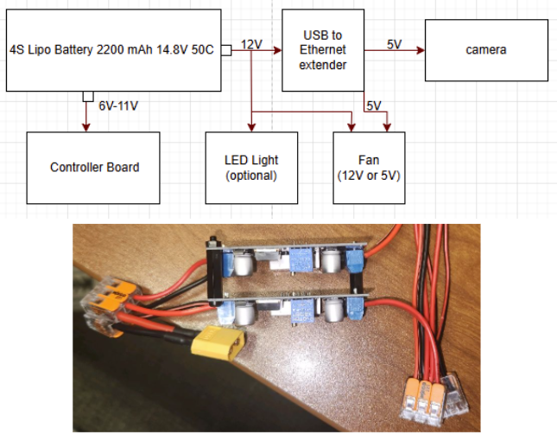
- 1 to 2 power connection
- 2 buck converters (9V,12V)
- 1 to 3 power connection (12V) (USB to Ethernet Extender,LED Light,Fan)
- Run Time
  - 2.2 Ah Battery
  - Run Time (1.15 h)

- Electronics tray
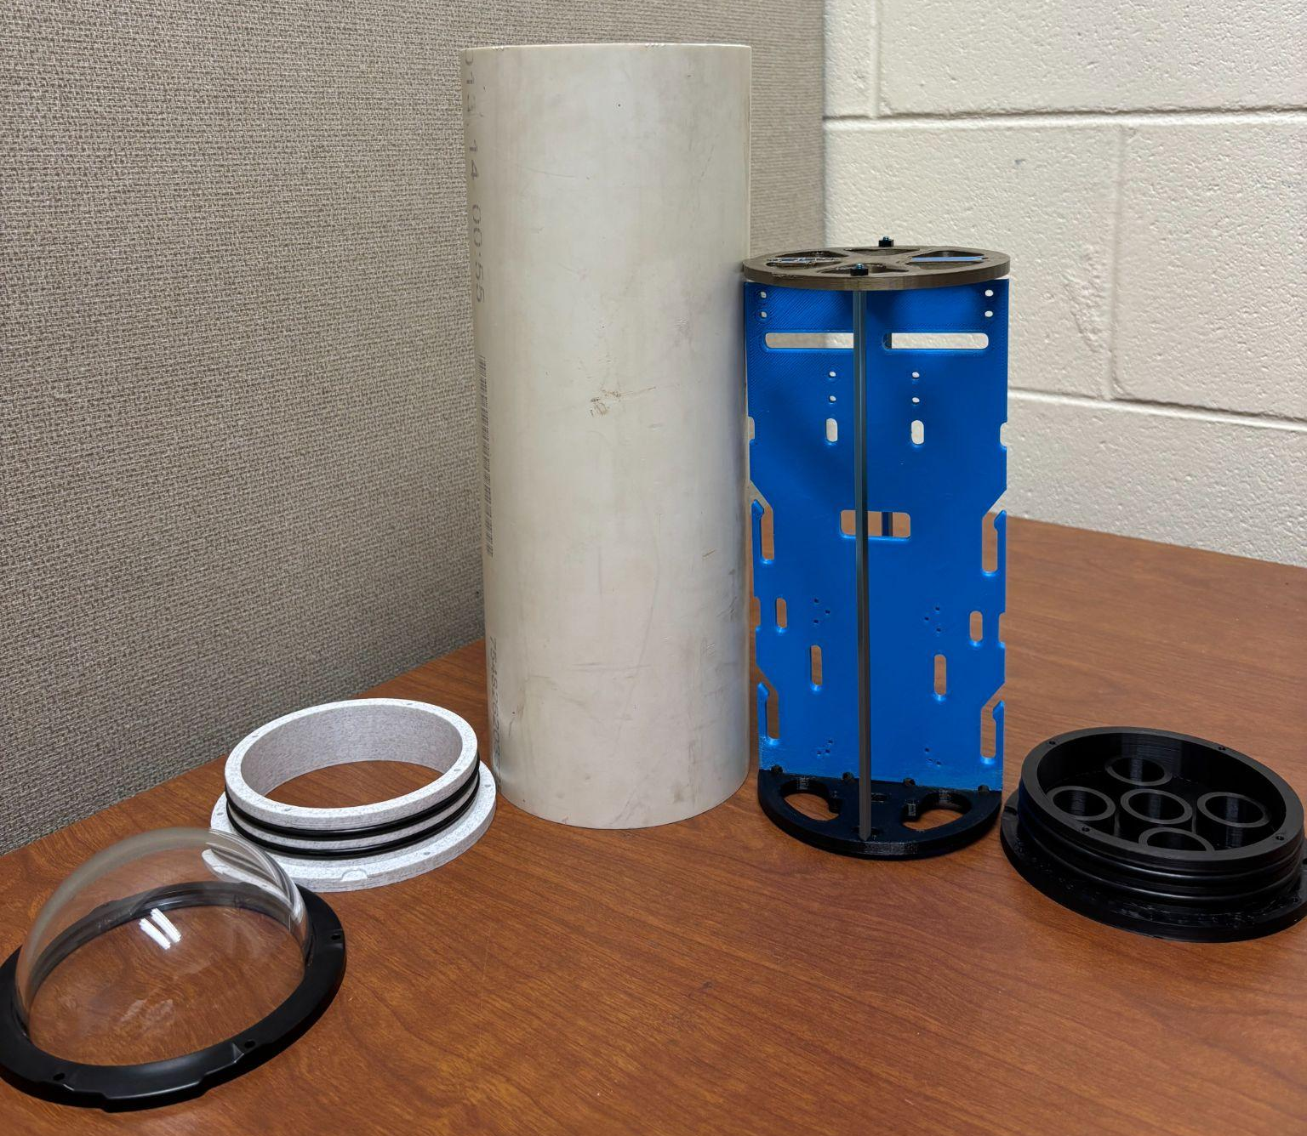
- Houses all non waterproof electronics
  - USB to ethernet extender, batteries, controller board, connections, Fan,Voltameter,Camera
  - Top(Main electronics, connections)
  - Bottom(Batteries,Buck Converters,connections)

Software Architecture:
The system comprises three key Python scripts, each serving a specific role in the software architecture. These are main.py, acce_test.py, and dashboard.py. The applications that were used are Thonny and Visual Studio Code. Pseudocode will be provided in the appendix section.

Applications:
download python
https://www.python.org/downloads/
download vs code
https://code.visualstudio.com/
install python extension
open the folder as a project
python -m pip install pygame
python -m pip install serial
pip install pyserial
pip install opencv-python opencv-python-headless
py -m pip install pillow

Code:
- The main.py script runs directly on the XRP Beta board and controls the ROV’s hardware. It initializes all the motors, sensors (IMU, pressure, and internal temperature), and sets up a serial communication loop. When it receives joystick commands from the laptop, it updates the PWM values for the thrusters. If depth-hold is enabled, it uses a PID controller to automatically adjust the vertical thrusters to maintain the set depth. It continuously reads sensor data and sends back telemetry information over serial to the laptop, including motor speeds, orientation, depth, and temperatures.
- The acce_test.py script is the bridge between the Xbox controller and the XRP board. It reads real-time joystick inputs, translates them into motor commands, and sends those as PWM values over a serial connection to the XRP. It also listens for telemetry data returned from the XRP and updates a shared telemetry dictionary. It launches the dashboard GUI in a background thread. Additionally, the A, Y, and B buttons are mapped to toggle depth hold, set the target depth, and zero the relative depth, respectively.
- The dashboard.py script is responsible for the real-time graphical interface. It displays all telemetry data (joystick inputs, IMU readings, temperatures, depth, and motor values) in a simple tkinter GUI. It also shows a live camera feed from a connected webcam and allows the user to start/stop video recording with a single button. The interface updates regularly using background threads and tkinter’s scheduling system, ensuring smooth visuals and consistent feedback for the user.
Note: All custom sensor drivers (imu.py, lps33.py, and PicoSensor.py) must be uploaded to the XRP Beta board and should be left unchanged unless hardware is modified. These files are essential for correct sensor communication and telemetry output. The driver files are available through WPI library and Raspberry Pi Pico library online.

Integration

Submersible Outer Body Assembly
*This process begins once wiring and electronics are fully assembled and are fit into the waterproof hull.
*Thrusters should be mounted onto rear and front lower body pieces already and wires fed through their respective holes before beginning this process.
- Lay rear and front lower body pieces on a flat surface and seat the lips onto each other until the screw holes are aligned. (Pictured below)
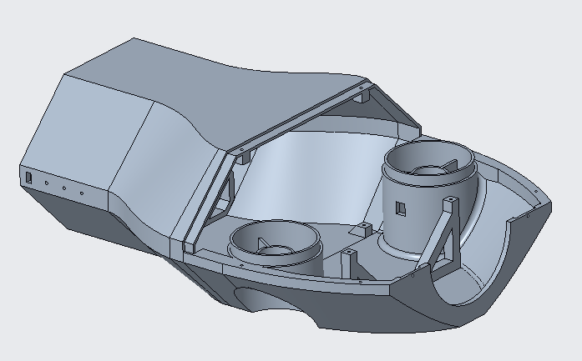
- Slide the waterproof hull (PVC pipe) rear first into the rear body piece until fully seated between the clamps and on the integrated stops. Then attach the clamp to the front lower body piece and over the waterproof hull. Tighten the 2 M3x14mm screws until the waterproof hull is secured. (Pictured below).
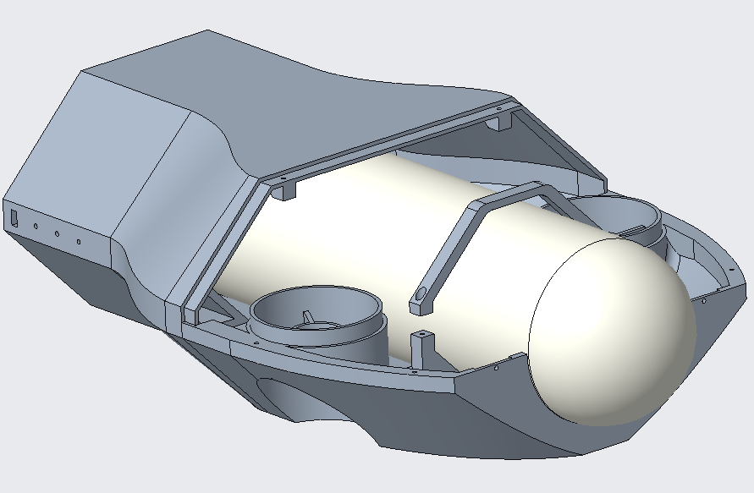
- Place the front upper body piece onto the front lower body piece, making sure to line up the vertical motor housings and press down firmly. The front latches should snap into place. Begin screwing all body pieces together using M3x10mm screws, starting with the mating joint between the rear and front upper body piece, then the front 2 holes next to the dome. Then finish with the 4 screws along the sides and finally flip the submersible over and screw in the corresponding mating surface between the rear and front lower body piece. (Pictured below)
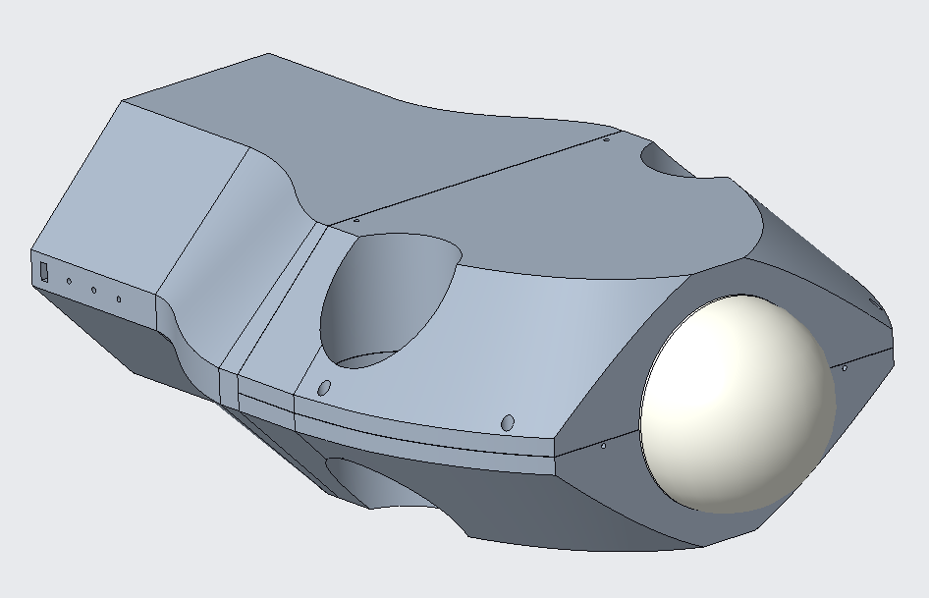
- Once all electrical connections are made, run the ethernet tether through the hole in the end cap and seat the end cap into its respective circular cutout on the rear body piece, making sure to line the 2 M3 holes up. Then screw into place using M3x10mm screws. (Pictured below)
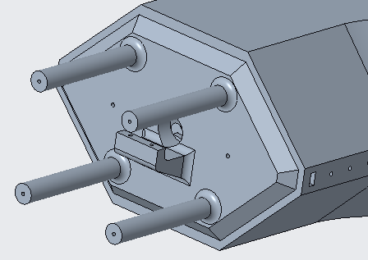

- Finally, clamp the tether using the tether clamp piece onto the end cap using two M3x10mm screws, tightening until the tether cannot be pulled through. (Pictured below)
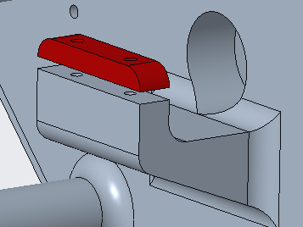

Operation Instructions

Startup
- Ensure the 4S 14.8V LiPo battery is fully charged before use.
- Connect the battery to the power distribution block inside the hull.
- Connect the tether to both the submersible vehicle and the topside control station.
- Power on the XRP controller board and confirm the onboard LED lights up.
- Connect the Xbox controller to the PC.
- Launch the control software (/scripts/thruster_control.py and /scripts/camera_feed.py) on the PC.
- Verify that the live camera feed is active.

Basic Controls
- Left joystick: Forward and backward motion
- Right joystick: Turning and vertical movement (ascend/descend)

Operation Notes
- Operate only in clean, freshwater environments such as pools.
- Do not exceed a depth of 20 feet.
- Avoid contact with pool walls and floors at high speeds.
- Always monitor the camera feed for surroundings and orientation.
- If using an external power supply instead of the battery, ensure it matches the voltage and current specifications.

Shutdown Procedure
- Safely surface the vehicle.
- Exit the control software on the PC.
- Power off the XRP controller.
- Disconnect the battery and tether.
- Wipe down the vehicle and dry all components before storage.
- Store the battery in a fire-safe bag and recharge if needed.

Safety Tips
- Never operate the submersible unattended.
- Keep electronics away from water during setup.
- Do not touch exposed wiring while the system is powered.

Troubleshooting

Issue: No power to vehicle
Possible Cause: Battery not connected or dead
Solution: Ensure the 4S battery is fully charged and securely connected. Check battery voltage.

Issue: Thrusters do not respond
Possible Cause: ESC or motor connection is loose or damaged
Solution: Inspect motor wires and ESC connectors. Ensure PWM cables are connected to the correct pins on the XRP board.

Issue: Vehicle only turns in one direction
Possible Cause: One or more thrusters not functioning
Solution: Test each thruster individually using direct commands. Replace any non-responsive thruster or ESC.

Issue: Camera feed is black or frozen
Possible Cause: Camera not receiving power or loose SPI/USB connection
Solution: Reconnect camera cables. Restart the /scripts/camera_feed.py script.

Issue: Game controller not recognized
Possible Cause: Driver issue or controller not paired
Solution: Unplug and reconnect the controller. Reboot PC. Confirm it’s recognized in control software.

Issue: Vehicle drifts or tilts uncontrollably
Possible Cause: Uneven weight distribution or thrusters mounted off-axis
Solution: Adjust ballast skids or reposition internal components for better center of gravity. Check thruster alignment.

Issue: No communication via tether
Possible Cause: Broken wire or poor connector seal
Solution: Test continuity across tether wires. Check for water damage or exposed connectors. Replace tether if needed.

Issue: Water intrusion in hull
Possible Cause: O-ring damaged, epoxy seal failed
Solution: Inspect and replace O-rings. Reapply waterweld epoxy to affected penetrators. Test hull under shallow pressure.

Issue: XRP board not booting
Possible Cause: Firmware issue or electrical short
Solution: Reflash firmware if unresponsive. Inspect board for signs of corrosion or loose solder joints.

Issue: Battery drains too quickly
Possible Cause: Overuse of thrusters or other components
Solution: Reduce power usage. Avoid constant full-throttle operation. Use external power supply for bench testing.

Appendix A: Pseudocode

main.py:
Initialize PWM pins for motors (mL, mR, m3, m4) at 50 Hz
Initialize I2C-connected IMU sensor
Initialize I2C-connected LPS33 pressure sensor
Initialize onboard internal temperature sensor
Initialize LED pin for activity indicator
Start polling for serial input

Set PID constants (Kp, Ki, Kd)
Set PID state variables (integral, last_error, last_time)
Set initial depth hold settings (depth_hold_enabled = False, target_depth = 0.0)
Set depth_offset = 0.0 for relative depth

Define hold_depth(current_depth):
Compute error between target_depth and current depth
Compute time delta (dt)
Compute PID terms (integral and derivative)
Calculate effort using PID formula
Clamp effort between -1 and 1
Convert effort to PWM pulse width and return it

Start main loop:
Toggle LED to indicate activity

If serial input is available:
Read a line from serial

If command is "ZERO_DEPTH":
Read pressure from LPS33
Set depth_offset = pressure converted to cm
Continue to next iteration

Parse incoming command line: pwm1, pwm2, pwm3, pwm4, depth_hold_flag, target_depth

If depth hold is enabled:
Read pressure from LPS33
Convert to depth_cm
Calculate relative_depth_cm = depth_cm - depth_offset
Compute PWM output for vertical thrusters (m3 and m4) using hold_depth()

Apply all PWM values to motors
Read IMU values (acceleration, gyroscope, pitch, roll, yaw)
Read pressure and temperature from LPS33
Convert pressure to depth_cm
Read internal temperature from onboard ADC

Print telemetry string:
Includes motor values, IMU, depth, pressure, temperatures, depth_hold state, and relative depth

End loop and repeat

Acce_test.py:
Import joystick and serial libraries
Import dashboard thread and shared telemetry dictionary
Initialize serial connection to XRP (set COM port)

Initialize pygame and connect to Xbox controller

Define helper functions:
clamp(value): restrict value to [-1.0, 1.0]
apply_deadzone(value): remove small joystick noise
normalize_axis(raw_value): apply clamp and deadzone
map_effort_to_pwm(effort): convert joystick effort to PWM signal

Start dashboard thread (runs GUI in background)

Initialize IMU data and depth hold tracking variables
Initialize last button press trackers

Start main loop:
Poll controller inputs

Read left and right joystick values for:
- forward (surge)
- yaw (rotate)
- pitch and roll (heave and tilt)

Read button states: A, Y, B

If A is newly pressed:
Toggle depth hold flag
Print status message

If Y is newly pressed:
Set target_depth = current relative depth from telemetry
Print new target message

If B is newly pressed:
Send "ZERO_DEPTH" command to XRP
Print confirmation

If all joystick axes are 0:
Set all PWM signals to neutral (4915)
Else:
Map joystick inputs to motor efforts (surge, yaw, pitch, roll)
Convert to PWM values for m1–m4

Create command string with pwm1–pwm4, depth hold flag, and target depth
Send command to XRP over serial

If serial response is available:
Read and decode line
If line starts with "TELEMETRY:":
Parse data into:
- PWM values
- IMU readings
- Pressure + temperature + depth
- Depth hold state
- Relative depth
Update shared telemetry dictionary

Update telemetry dictionary with joystick and PWM values

Sleep briefly to limit CPU usage
Repeat loop

dashboard.py:
Import tkinter for GUI, threading for updates, and OpenCV for camera
Import PIL for displaying camera frames in tkinter

Initialize shared telemetry dictionary
Initialize video recording state (recording = False, video_writer = None)

Define update_loop(labels):
Loop forever:
Try:
Update each GUI label with current telemetry data:
- Joystick values
- Thruster PWM values
- IMU values (acceleration, gyro, orientation)
- External and internal temperatures
- Depth (absolute and relative)
- Depth hold status and target
Set color based on depth hold state
Except:
Pass (ignore GUI errors)
Sleep briefly (0.1s)

Define update_camera(cam_label, cap, root):
Read one frame from camera
If successful:
Convert frame to RGB
Display in GUI using ImageTk
If recording:
Write frame to video file
Schedule next update with root.after()

Define toggle_record():
If not recording:
Create new video file using timestamp
Start writing frames
Update button text to "Stop Recording"
Else:
Stop and release video writer
Reset button text to "Start Recording"

Define run_dashboard():
Create tkinter window
Create and pack labels for telemetry categories
Create and pack record button
Create and pack camera preview label

Open camera stream (usually `cv2.VideoCapture(2)`)

Start update loop in a background thread
Start update_camera loop using `root.after()`

Start tkinter mainloop()

Appendix B: Driver Files

imu.py:
# LSM6DSO 3D accelerometer and 3D gyroscope seneor micropython drive
# ver: 1.0
# License: MIT
# Author: shaoziyang (shaoziyang@micropython.org.cn)
# v1.0 2019.7

from imu_defs import *
from uctypes import struct, addressof
from machine import I2C, Pin, Timer, disable_irq, enable_irq
import time, math

class IMU():

_DEFAULT_IMU_INSTANCE = None

@classmethod
def get_default_imu(cls):
"""
Get the default XRP IMU instance. This is a singleton, so only one instance of the drivetrain will ever exist.
"""

if cls._DEFAULT_IMU_INSTANCE is None:
cls._DEFAULT_IMU_INSTANCE = cls()
cls._DEFAULT_IMU_INSTANCE.calibrate()
return cls._DEFAULT_IMU_INSTANCE

def __init__(self, scl_pin: int|str = "I2C_SCL_1", sda_pin: int|str = "I2C_SDA_1", addr=LSM_ADDR_PRIMARY):
# I2C values
self.i2c = I2C(id=1, scl=Pin(scl_pin), sda=Pin(sda_pin), freq=400000)
self.addr = addr

# Initialize member variables
self._reset_member_variables()

# Transmit and recieve buffers
self.tb = bytearray(1)
self.rb = bytearray(1)

# Copies of registers. Bytes and structs share the same memory
# addresses, so changing one changes the other
self.reg_ctrl1_xl_byte = bytearray(1)
self.reg_ctrl2_g_byte = bytearray(1)
self.reg_ctrl3_c_byte = bytearray(1)
self.reg_ctrl1_xl_bits = struct(addressof(self.reg_ctrl1_xl_byte), LSM_REG_LAYOUT_CTRL1_XL)
self.reg_ctrl2_g_bits = struct(addressof(self.reg_ctrl2_g_byte), LSM_REG_LAYOUT_CTRL2_G)
self.reg_ctrl3_c_bits = struct(addressof(self.reg_ctrl3_c_byte), LSM_REG_LAYOUT_CTRL3_C)

# Create timer
self.update_timer = Timer(-1)

# Check if the IMU is connected
if not self.is_connected():
# TODO - do somehting intelligent here
pass

# Reset sensor to clear any previous configuration
# reset() also sets the board to the default config
self.reset()

def _default_config(self):
# Enable block data update
self._set_bdu()

# Set default scale for each sensor
self.acc_scale('16g')
self.gyro_scale('2000dps')

# Set default rate for each sensor
self.acc_rate('208Hz')
self.gyro_rate('208Hz')

"""
The following are private helper methods to read and write registers, as well as to convert the read values to the correct unit.
"""

def _reset_member_variables(self):
# Vector of IMU measurements
self.irq_v = [[0, 0, 0], [0, 0, 0]]

# Sensor offsets
self.gyro_offsets = [0,0,0]
self.acc_offsets = [0,0,0]

# Scale factors when ranges are changed
self._acc_scale_factor = 1
self._gyro_scale_factor = 1

# Angle integrators
self.running_pitch = 0
self.running_yaw = 0
self.running_roll = 0

def _int16(self, d):
return d if d < 0x8000 else d - 0x10000

def _setreg(self, reg, dat):
self.tb[0] = dat
self.i2c.writeto_mem(self.addr, reg, self.tb)

def _getreg(self, reg):
self.i2c.readfrom_mem_into(self.addr, reg, self.rb)
return self.rb[0]

def _getregs(self, reg, num_bytes):
rx_buf = bytearray(num_bytes)
self.i2c.readfrom_mem_into(self.addr, reg, rx_buf)
return rx_buf

def _get2reg(self, reg):
return self._getreg(reg) + self._getreg(reg+1) * 256

def _r_w_reg(self, reg, dat, mask):
self._getreg(reg)
self.rb[0] = (self.rb[0] & mask) | dat
self._setreg(reg, self.rb[0])

def _set_bdu(self, bdu = True):
"""
Sets Block Data Update bit
"""
self.reg_ctrl3_c_byte[0] = self._getreg(LSM_REG_CTRL3_C)
self.reg_ctrl3_c_bits.BDU = bdu
self._setreg(LSM_REG_CTRL3_C, self.reg_ctrl3_c_byte[0])

def _set_if_inc(self, if_inc = True):
"""
Sets InterFace INCrement bit
"""
self.reg_ctrl3_c_byte[0] = self._getreg(LSM_REG_CTRL3_C)
self.reg_ctrl3_c_bits.IF_INC = if_inc
self._setreg(LSM_REG_CTRL3_C, self.reg_ctrl3_c_byte[0])

def _raw_to_mg(self, raw):
return self._int16((raw[1] << 8) | raw[0]) * LSM_MG_PER_LSB_2G * self._acc_scale_factor

def _raw_to_mdps(self, raw):
return self._int16((raw[1] << 8) | raw[0]) * LSM_MDPS_PER_LSB_125DPS * self._gyro_scale_factor

"""
Public facing API Methods
"""

def is_connected(self):
"""
Checks whether the IMU is connected

:return: True if WHO_AM_I value is correct, otherwise False
:rtype: bool
"""
who_am_i = self._getreg(LSM_REG_WHO_AM_I)
return who_am_i == LSM_WHO_AM_I_VALUE

def reset(self, wait_for_reset = True, wait_timeout_ms = 100):
"""
Resets the IMU, and restores all registers to their default values

:param wait_for_reset: Whether to wait for reset to complete
:type wait_for_reset: bool
:param wait_timeout_ms: Timeout in milliseconds when waiting for reset
:type wait_timeout_ms: int
:return: False if timeout occurred, otherwise True
:rtype: bool
"""
# Stop timer
self._stop_timer()

# Reset member variables
self._reset_member_variables()

# Set BOOT and SW_RESET bits
self.reg_ctrl3_c_byte[0] = self._getreg(LSM_REG_CTRL3_C)
self.reg_ctrl3_c_bits.BOOT = 1
self.reg_ctrl3_c_bits.SW_RESET = 1
self._setreg(LSM_REG_CTRL3_C, self.reg_ctrl3_c_byte[0])

# Wait for reset to complete, if requested
if wait_for_reset:
# Loop with timeout
t0 = time.ticks_ms()
while time.ticks_ms() < (t0 + wait_timeout_ms):
# Check if register has returned to default value (0x04)
self.reg_ctrl3_c_byte[0] = self._getreg(LSM_REG_CTRL3_C)
if self.reg_ctrl3_c_byte[0] == 0x04:
self._default_config()
self._start_timer()
return True
# Timeout occurred
# Attempt to set default config anyways
self._default_config()
self._start_timer()
return False
else:
self._default_config()
self._start_timer()
return True

def get_acc_x(self):
"""
:return: The current reading for the accelerometer's X-axis, in mg
:rtype: int
"""
# Burst read data registers
raw_bytes = self._getregs(LSM_REG_OUTX_L_A, 2)

# Convert raw data to mg's
return self._raw_to_mg(raw_bytes[0:2]) - self.acc_offsets[0]

def get_acc_y(self):
"""
:return: The current reading for the accelerometer's Y-axis, in mg
:rtype: int
"""
# Burst read data registers
raw_bytes = self._getregs(LSM_REG_OUTY_L_A, 2)

# Convert raw data to mg's
return self._raw_to_mg(raw_bytes[0:2]) - self.acc_offsets[1]

def get_acc_z(self):
"""
:return: The current reading for the accelerometer's Z-axis, in mg
:rtype: int
"""
# Burst read data registers
raw_bytes = self._getregs(LSM_REG_OUTZ_L_A, 2)

# Convert raw data to mg's
return self._raw_to_mg(raw_bytes[0:2]) - self.acc_offsets[2]

def get_acc_rates(self):
"""
:return: the list of readings from the Accelerometer, in mg. The order of the values is x, y, z.
:rtype: list<int>
"""
# Burst read data registers
raw_bytes = self._getregs(LSM_REG_OUTX_L_A, 6)

# Convert raw data to mg's
self.irq_v[0][0] = self._raw_to_mg(raw_bytes[0:2]) - self.acc_offsets[0]
self.irq_v[0][1] = self._raw_to_mg(raw_bytes[2:4]) - self.acc_offsets[1]
self.irq_v[0][2] = self._raw_to_mg(raw_bytes[4:6]) - self.acc_offsets[2]

return self.irq_v[0]

def get_gyro_x_rate(self):
"""
Individual axis read for the Gyroscope's X-axis, in mdps
"""
# Burst read data registers
raw_bytes = self._getregs(LSM_REG_OUTX_L_G, 2)

# Convert raw data to mdps
return self._raw_to_mdps(raw_bytes[0:2]) - self.gyro_offsets[0]

def get_gyro_y_rate(self):
"""
Individual axis read for the Gyroscope's Y-axis, in mdps
"""
# Burst read data registers
raw_bytes = self._getregs(LSM_REG_OUTY_L_G, 2)

# Convert raw data to mdps
return self._raw_to_mdps(raw_bytes[0:2]) - self.gyro_offsets[1]

def get_gyro_z_rate(self):
"""
Individual axis read for the Gyroscope's Z-axis, in mdps
"""
# Burst read data registers
raw_bytes = self._getregs(LSM_REG_OUTZ_L_G, 2)

# Convert raw data to mdps
return self._raw_to_mdps(raw_bytes[0:2]) - self.gyro_offsets[2]

def get_gyro_rates(self):
"""
Retrieves the array of readings from the Gyroscope, in mdps
The order of the values is x, y, z.
"""
# Burst read data registers
raw_bytes = self._getregs(LSM_REG_OUTX_L_G, 6)

# Convert raw data to mdps
self.irq_v[1][0] = self._raw_to_mdps(raw_bytes[0:2]) - self.gyro_offsets[0]
self.irq_v[1][1] = self._raw_to_mdps(raw_bytes[2:4]) - self.gyro_offsets[1]
self.irq_v[1][2] = self._raw_to_mdps(raw_bytes[4:6]) - self.gyro_offsets[2]

return self.irq_v[1]

def get_acc_gyro_rates(self):
"""
Get the accelerometer and gyroscope values in mg and mdps in the form of a 2D array.
The first row is the acceleration values, the second row is the gyro values.
The order of the values is x, y, z.
"""
# Burst read data registers
raw_bytes = self._getregs(LSM_REG_OUTX_L_G, 12)

# Convert raw data to mg's and mdps
self.irq_v[0][0] = self._raw_to_mg(raw_bytes[6:8]) - self.acc_offsets[0]
self.irq_v[0][1] = self._raw_to_mg(raw_bytes[8:10]) - self.acc_offsets[1]
self.irq_v[0][2] = self._raw_to_mg(raw_bytes[10:12]) - self.acc_offsets[2]
self.irq_v[1][0] = self._raw_to_mdps(raw_bytes[0:2]) - self.gyro_offsets[0]
self.irq_v[1][1] = self._raw_to_mdps(raw_bytes[2:4]) - self.gyro_offsets[1]
self.irq_v[1][2] = self._raw_to_mdps(raw_bytes[4:6]) - self.gyro_offsets[2]

return self.irq_v

def get_pitch(self):
"""
Get the pitch of the IMU in degrees. Unbounded in range

:return: The pitch of the IMU in degrees
:rtype: float
"""
return self.running_pitch

def get_yaw(self):
"""
Get the yaw (heading) of the IMU in degrees. Unbounded in range

:return: The yaw (heading) of the IMU in degrees
:rtype: float
"""
return self.running_yaw

def get_heading(self):
"""
Get's the heading of the IMU, but bounded between [0, 360)

:return: The heading of the IMU in degrees, bound between [0, 360)
:rtype: float
"""
return self.running_yaw % 360

def get_roll(self):
"""
Get the roll of the IMU in degrees. Unbounded in range

:return: The roll of the IMU in degrees
:rtype: float
"""
return self.running_roll

def reset_pitch(self):
"""
Reset the pitch to 0
"""
self.running_pitch = 0

def reset_yaw(self):
"""
Reset the yaw (heading) to 0
"""
self.running_yaw = 0

def reset_roll(self):
"""
Reset the roll to 0
"""
self.running_roll = 0

def set_pitch(self, pitch):
"""
Set the pitch to a specific angle in degrees

:param pitch: The pitch to set the IMU to
:type pitch: float
"""
self.running_pitch = pitch

def set_yaw(self, yaw):
"""
Set the yaw (heading) to a specific angle in degrees

:param yaw: The yaw (heading) to set the IMU to
:type yaw: float
"""
self.running_yaw = yaw

def set_roll(self, roll):
"""
Set the roll to a specific angle in degrees

:param roll: The roll to set the IMU to
:type roll: float
"""
self.running_roll = roll

def temperature(self):
"""
Read the temperature of the LSM6DSO in degrees Celsius

:return: The temperature of the LSM6DSO in degrees Celsius
:rtype: float
"""
# The LSM6DSO's temperature can be read from the OUT_TEMP_L register
# We use OUT_TEMP_L+1 if OUT_TEMP_L cannot be read
try:
return self._int16(self._get2reg(LSM_REG_OUT_TEMP_L))/256 + 25
except MemoryError:
return self._temperature_irq()

def _temperature_irq(self):
# Helper function for temperature() to read the alternate temperature register
self._getreg(LSM_REG_OUT_TEMP_L+1)
if self.rb[0] & 0x80:
self.rb[0] -= 256
return self.rb[0] + 25

def acc_scale(self, value=None):
"""
Set the accelerometer scale in g. The scale can be:
'2g', '4g', '8g', or '16g'
Pass in no parameters to retrieve the current value
"""
# Get register value
self.reg_ctrl1_xl_byte[0] = self._getreg(LSM_REG_CTRL1_XL)
# Check if the provided value is in the dictionary
if value not in LSM_ACCEL_FS:
# Return string representation of this value
index = list(LSM_ACCEL_FS.values()).index(self.reg_ctrl1_xl_bits.FS_XL)
return list(LSM_ACCEL_FS.keys())[index]
else:
# Set value as requested
self.reg_ctrl1_xl_bits.FS_XL = LSM_ACCEL_FS[value]
self._setreg(LSM_REG_CTRL1_XL, self.reg_ctrl1_xl_byte[0])
# Update scale factor for converting raw data
self._acc_scale_factor = int(value.rstrip('g')) // 2

def gyro_scale(self, value=None):
"""
Set the gyroscope scale in dps. The scale can be:
'125', '250', '500', '1000', or '2000'
Pass in no parameters to retrieve the current value
"""
# Get register value
self.reg_ctrl2_g_byte[0] = self._getreg(LSM_REG_CTRL2_G)
# Check if the provided value is in the dictionary
if value not in LSM_GYRO_FS:
# Return string representation of this value
index = list(LSM_GYRO_FS.values()).index(self.reg_ctrl2_g_bits.FS_G)
return list(LSM_GYRO_FS.keys())[index]
else:
# Set value as requested
self.reg_ctrl2_g_bits.FS_G = LSM_GYRO_FS[value]
self._setreg(LSM_REG_CTRL2_G, self.reg_ctrl2_g_byte[0])
# Update scale factor for converting raw data
self._gyro_scale_factor = int(value.rstrip('dps')) // 125

def acc_rate(self, value=None):
"""
Set the accelerometer rate in Hz. The rate can be:
'0Hz', '12.5Hz', '26Hz', '52Hz', '104Hz', '208Hz', '416Hz', '833Hz', '1660Hz', '3330Hz', '6660Hz'
Pass in no parameters to retrieve the current value
"""
# Get register value
self.reg_ctrl1_xl_byte[0] = self._getreg(LSM_REG_CTRL1_XL)
# Check if the provided value is in the dictionary
if value not in LSM_ODR:
# Return string representation of this value
index = list(LSM_ODR.values()).index(self.reg_ctrl1_xl_bits.ODR_XL)
return list(LSM_ODR.keys())[index]
else:
# Set value as requested
self.reg_ctrl1_xl_bits.ODR_XL = LSM_ODR[value]
self._setreg(LSM_REG_CTRL1_XL, self.reg_ctrl1_xl_byte[0])

def gyro_rate(self, value=None):
"""
Set the gyroscope rate in Hz. The rate can be:
'0Hz', '12.5Hz', '26Hz', '52Hz', '104Hz', '208Hz', '416Hz', '833Hz', '1660Hz', '3330Hz', '6660Hz'
Pass in no parameters to retrieve the current value
"""
# Get register value
self.reg_ctrl2_g_byte[0] = self._getreg(LSM_REG_CTRL2_G)
# Check if the provided value is in the dictionary
if value not in LSM_ODR:
# Return string representation of this value
index = list(LSM_ODR.values()).index(self.reg_ctrl1_xl_bits.ODR_G)
return list(LSM_ODR.keys())[index]
else:
# Set value as requested
self.reg_ctrl2_g_bits.ODR_G = LSM_ODR[value]
self._setreg(LSM_REG_CTRL2_G, self.reg_ctrl2_g_byte[0])

# Update timer frequency
self.timer_frequency = int(value.rstrip('Hz'))
self._start_timer()

def calibrate(self, calibration_time:float=1, vertical_axis:int= 2):
"""
Collect readings for [calibration_time] seconds and calibrate the IMU based on those readings
Do not move the robot during this time
Assumes the board to be parallel to the ground. Please use the vertical_axis parameter if that is not correct

:param calibration_time: The time in seconds to collect readings for
:type calibration_time: float
:param vertical_axis: The axis that is vertical. 0 for X, 1 for Y, 2 for Z
:type vertical_axis: int
"""
self._stop_timer()
self.acc_offsets = [0,0,0]
self.gyro_offsets = [0,0,0]
avg_vals = [[0,0,0],[0,0,0]]
num_vals = 0
# Wait a bit for sensor to start measuring (data registers may default to something nonsensical)
time.sleep(.1)
start_time = time.ticks_ms()
while time.ticks_ms() < start_time + calibration_time*1000:
cur_vals = self.get_acc_gyro_rates()
# Accelerometer averages
avg_vals[0][0] += cur_vals[0][0]
avg_vals[0][1] += cur_vals[0][1]
avg_vals[0][2] += cur_vals[0][2]
# Gyroscope averages
avg_vals[1][0] += cur_vals[1][0]
avg_vals[1][1] += cur_vals[1][1]
avg_vals[1][2] += cur_vals[1][2]
# Increment counter and wait for next loop
num_vals += 1
time.sleep(1 / self.timer_frequency)

# Compute averages
avg_vals[0][0] /= num_vals
avg_vals[0][1] /= num_vals
avg_vals[0][2] /= num_vals
avg_vals[1][0] /= num_vals
avg_vals[1][1] /= num_vals
avg_vals[1][2] /= num_vals

avg_vals[0][vertical_axis] -= 1000 #in mg

self.acc_offsets = avg_vals[0]
self.gyro_offsets = avg_vals[1]
self._start_timer()

def _start_timer(self):
self.update_timer.init(freq=self.timer_frequency, callback=lambda t:self._update_imu_readings())

def _stop_timer(self):
self.update_timer.deinit()

def _update_imu_readings(self):
# Called every tick through a callback timer
self.get_gyro_rates()
delta_pitch = self.irq_v[1][0] / 1000 / self.timer_frequency
delta_roll = self.irq_v[1][1] / 1000 / self.timer_frequency
delta_yaw = self.irq_v[1][2] / 1000 / self.timer_frequency

state = disable_irq()
self.running_pitch += delta_pitch
self.running_roll += delta_roll
self.running_yaw += delta_yaw
enable_irq(state)

imu_defs.py:
from uctypes import BFUINT8, BF_POS, BF_LEN
from micropython import const

"""
Possible I2C addresses
"""
LSM_ADDR_PRIMARY = const(0x6B)
LSM_ADDR_SECONDARY = const(0x6A)

"""
Register addresses
"""
LSM_REG_WHO_AM_I = const(0x0F)
LSM_REG_CTRL1_XL = const(0x10)
LSM_REG_CTRL2_G = const(0x11)
LSM_REG_CTRL3_C = const(0x12)
LSM_REG_OUT_TEMP_L = const(0x20)
LSM_REG_OUT_TEMP_H = const(0x21)
LSM_REG_OUTX_L_G = const(0x22)
LSM_REG_OUTY_L_G = const(0x24)
LSM_REG_OUTZ_L_G = const(0x26)
LSM_REG_OUTX_L_A = const(0x28)
LSM_REG_OUTY_L_A = const(0x2A)
LSM_REG_OUTZ_L_A = const(0x2C)

"""
Bit field struct definitions of registers
"""
LSM_REG_LAYOUT_CTRL1_XL = {
"ODR_XL" : BFUINT8 | 4 << BF_POS | 4 << BF_LEN,
"FS_XL" : BFUINT8 | 2 << BF_POS | 2 << BF_LEN,
"LPF2_XL_EN" : BFUINT8 | 1 << BF_POS | 1 << BF_LEN,
}
LSM_REG_LAYOUT_CTRL2_G = {
"ODR_G" : BFUINT8 | 4 << BF_POS | 4 << BF_LEN,
"FS_G" : BFUINT8 | 1 << BF_POS | 3 << BF_LEN,
}
LSM_REG_LAYOUT_CTRL3_C = {
"BOOT" : BFUINT8 | 7 << BF_POS | 1 << BF_LEN,
"BDU" : BFUINT8 | 6 << BF_POS | 1 << BF_LEN,
"H_LACTIVE" : BFUINT8 | 5 << BF_POS | 1 << BF_LEN,
"PP_OD" : BFUINT8 | 4 << BF_POS | 1 << BF_LEN,
"SIM" : BFUINT8 | 3 << BF_POS | 1 << BF_LEN,
"IF_INC" : BFUINT8 | 2 << BF_POS | 1 << BF_LEN,
"SW_RESET" : BFUINT8 | 0 << BF_POS | 1 << BF_LEN,
}

"""
Dictionaries for possible register settings
"""
LSM_ODR = {
"0Hz" : 0x0,
"12.5Hz" : 0x1,
"26Hz" : 0x2,
"52Hz" : 0x3,
"104Hz" : 0x4,
"208Hz" : 0x5,
"416Hz" : 0x6,
"833Hz" : 0x7,
"1660Hz" : 0x8,
"3330Hz" : 0x9,
"6660Hz" : 0xA,
}
LSM_ACCEL_FS = {
"2g" : 0x0,
"4g" : 0x2,
"8g" : 0x3,
"16g" : 0x1,
}
LSM_GYRO_FS = {
"125dps" : 0x1,
"250dps" : 0x0,
"500dps" : 0x2,
"1000dps" : 0x4,
"2000dps" : 0x6,
}

"""
Other contants
"""
LSM_WHO_AM_I_VALUE = 0x6C
LSM_MG_PER_LSB_2G = 0.061
LSM_MDPS_PER_LSB_125DPS = 4.375

pressure_test.py:
from machine import I2C
from lps33 import LPS33
import time

# Constants for freshwater and saltwater conversion
CM_CONVERT_FRESHWATER = 0.9778
CM_CONVERT_SALTWATER = 1.0038 # Use this if in saltwater

# User-configurable settings
USE_SALTWATER = False # Set True if you're testing in saltwater
depth_offset = -10 # Calibration offset
upper_limit = 40 # Depth range
bottom_limit = 50

# I2C and sensor init
i2c = I2C(1) # Qwiic port on XRP uses I2C(1)
sensor = LPS33(i2c)

def get_depth(pressure_hpa):
conv = CM_CONVERT_SALTWATER if USE_SALTWATER else CM_CONVERT_FRESHWATER
depth_cm = pressure_hpa / conv - depth_offset
return max(0.0, depth_cm)

while True:
try:
pressure, temp_c = sensor.read_all()
temp_f = temp_c * 9 / 5 + 32
depth = get_depth(pressure)
depth_ft = depth * 0.0328084

print(f"Temp: {temp_c:.2f} Â°C / {temp_f:.2f} Â°F")
print(f"Pressure: {pressure:.2f} hPa")
print(f"Depth: {depth:.2f} cm | {depth_ft:.2f} ft\n")

time.sleep(0.5)

except Exception as e:
print("Sensor read error:", e)
time.sleep(1)

lps33.py:
from machine import I2C
import time

LPS33_ADDR = 0x5D
LPS33_PRESS_OUT_XL = 0x28 | 0x80 # auto-increment flag
LPS33_TEMP_OUT_L = 0x2B | 0x80
LPS33_CTRL_REG1 = 0x10

class LPS33:
def __init__(self, i2c, address=LPS33_ADDR):
self.i2c = i2c
self.addr = address

# Proper config for LPS33HW: BDU=1, ODR=1Hz, LPF=enabled
# 0b10110000 = 0xB0
self.i2c.writeto_mem(self.addr, LPS33_CTRL_REG1, b'\xB0')

time.sleep(0.1) # Let it settle

self.read_all() # Discard first pressure/temp reading

def read_all(self):
# Read 5 bytes starting from pressure register
raw = self.i2c.readfrom_mem(self.addr, LPS33_PRESS_OUT_XL, 5)

# Pressure: 3 bytes (24-bit signed)
p = raw[0] | (raw[1] << 8) | (raw[2] << 16)
if p & 0x800000: # sign bit
p -= 1 << 24
pressure = p / 4096.0 # hPa

# Temperature: 2 bytes (16-bit signed)
t = raw[3] | (raw[4] << 8)
if t & 0x8000:
t -= 1 << 16
temperature = t / 100.0 # Â°C

return pressure, temperature

References
There are no sources in the current document.

